Public Engagement Plan

for the

City of Compton

Informing the Public for Participation in the Process of
Abolishing the LA Sheriff’s Department

Executive Summary 4
Introduction 6
Project Context: A History of Policing 7
Project Context: The Current State of Policing 9
Purpose, Promise, and Desired Outcomes 11
Level of Impact 13
Level of Engagement 13
The People of Los Angeles County 16
Race & Ethnicity 16
Class 17
Housing status 18
Incarceration Status 19
People living with disabilities 19
The People of Compton 19
Compton Students and Parents 20
City of Compton Homeowners 22
Public Safety Professionals 22
Los Angeles Sheriff's department (LASD) / Compton Station 22
Sheriff Civilian Oversight Commission 25
The Union 25
Fire Department / EMS 26
Non-Traditional Public Safety Professionals 26
Government / Municipal Agencies 26
Compton Mayor Emma Sharif 27
Dist. 2 Council Member Isaac Galvan 27
Captain Latonya Clark 28
Compton Chamber of Commerce 28
Community Anchors 29
Community Service Providers 29
Religious Groups 30
Local Gangs 30
School Districts 31
Hospitals 32
Activist groups 32
Black Lives Matter Los Angeles 32
Justice LA and LA Alternatives to Incarceration Initiative 33
Californians United for a Responsible Budget (CURB) 34
LA CAN 35
Social Justice Learning Institute 35
Influencers / Local Artists 36
Compton Art Walk 36
The Compton Cowboys 37
Discussion of potential barriers and suggestions for mitigation 37
Ineffective Facilitation 37
Awareness and Accessibility of Information 38
Lack of convenience - Time and Location 38
Language and Cultural Norms 38
Positions versus Interests 38
Political views 39
Biases (conscious and unconscious) 39
Cynicism and Distrust 39
Citizenship / Disenfranchisement / Disinterest 40
Stakeholder Summary 41
Pre-Engagement Phase 52
Part 1: Establish Team and Methods of Communication 53
Part 2: Educational Materials 53
Part 3: Location 54
Active Engagement Phase 55
Part 1: Inform the public of the BOS decision 55
Part 2: Educate the public regarding impact and significance 56
Part 3: Prepare the Public to Participate 58
Part 4: Community Resilience Celebration 59
Post-Engagement Phase 59
Recommended Next Steps 60
Resource Analysis 62
Pre-Engagement Phase: (8 months | $590,000.00) 62
Active Engagement Phase: (4 months | $144,000.00) 63
Post-Engagement Phase: (2 months | $16,000.00) 64
Budget 64
REFERENCES: 68
APPENDIX: 74

Executive Summary
The Los Angeles Board of Supervisors has made the monumental decision to abolish the Los Angeles Sheriff's Department. Given the magnitude of this decision, the Board has hired ProPublica, a public engagement specialist group to spearhead this project. Although this decision is unprecedented and will impact everyone living in Los Angeles County, the BOS has tasked us with beginning this work on a smaller scale at the city level in Compton, CA, an incorporated city in LA County. The City of Compton was selected as an excellent pilot location due to LASD's presence in the city, its central location, and the disproportionate impact of police violence in the area. Public engagement is nothing new, and by utilizing a variety of tools, we hope to create an effective public engagement plan that considers the people living in Los Angeles. Public engagement can take many shapes. We will begin with a comprehensive public engagement plan to Inform the public about essential, relevant information that will prepare them to participate in a subsequent public engagement program that will focus on re-imagining public safety in Los Angeles should look like in the future. Our goal is to serve as a conduit to ensure effective, efficient, equitable public participation as abolition work moves from theory to practice in the wake of increased police violence over the last decade.
Our main focus with this participatory process will be to educate participants about the historical and current historical context for the choice to pursue abolition, existing alternatives to police and incarceration, and the work being done to achieve abolition by local advocacy groups, social justice programs, community organizations, and government agencies. The Inform stage is often overlooked, but we believe that if done correctly we could lay the foundation by providing the community with the tools they need to self advocate and increase participation. This paper is the culmination of our study into a participatory process for the City of Compton. It will highlight the key issues, identify all key stakeholders, outline methods and communication strategies to reach all stakeholders, and provide a plan for engagement.
Our scope of work will be broken down into three different stages of engagement. In the engagement phase, we provide many different workshops and webinars to encourage the public to participate and, therefore, increase their knowledge and list of resources to allow them to self-advocate in the next phase of the process leading up to abolition. Our first step in the active engagement process is the pre-engagement phase in which the team finds its footing and works on establishing methods of communication, preparing educational materials, and identifying locations that are accessible and could host events. After this step is completed we move on to the primary engagement phase in which we are directly involved with the public. Our final step to the engagement phase is the post-engagement that closes the loop on this process, collects our findings and feedback into a cumulative report.

SECTION 1
Scope of the Project, Level of Impact, and Level of Engagement

Introduction
We are a professional stakeholder engagement consulting firm known for creating public engagement plans that focus on equitable, meaningful public participation methods. We have been hired by the Los Angeles Board of Supervisors (BOS) to involve stakeholders in re-imagining public safety following the BOS decision to abolish the Los Angeles Sheriff’s Department (LASD), beginning with a comprehensive public engagement plan to inform the public about essential, relevant information that will prepare them to participate in subsequent public engagement events focused on re-imagining what public safety in Los Angeles should look like in the future. Our goal is to serve as a conduit to ensure effective, efficient, equitable public participation as abolition work moves from theory to practice in the wake of increased police violence over the last decade. It is essential to acknowledge how current public safety enforcers evolved from the need to monitor and collect enslaved people, as they were capital and the capitalist system that America’s budding success depended on was fueled by the work they performed. Further, it is imperative to address the nature in which white supremacy is deeply entrenched in policing and imprisonment, and we must uproot this evil so it cannot continue to flourish unaddressed. Public participation is essential to this operation because it will truly impact us all as we begin to imagine what public safety will look like in a police-free future.
Given the huge impact that the outcome of this process will have on the county of Los Angeles, the BOS has tasked us with beginning this work on a smaller scale at the city level in Compton, CA, an incorporated city in LA. The City of Compton was selected as an excellent pilot location due to LASD presence in the city, its central location, and the disproportionate impact of police violence in the area. Compton has already been exposed to public safety reform, having disbanded the Compton Police Department in 2000 after corruption within the force came to light. Since then, the LASD has fulfilled Compton’s public safety needs. From the beginning, there have been concerns about the power differential and marginalization of people with low incomes in community decisions. The City of Compton is not exempt from this sentiment; it is home to people from all walks of life, and this plan seeks to involve those members of the community who might not usually be included. Charts like the Ladder of participation devised by Sherry Arnstein in 1969 and the "Spectrum of Public Participation created by the International Association for Public Participation" were intended to clarify how much "say" community members would have in various stages of the participatory process (Nabatchi & Leighninger, 2015). Like everything else, these resources are tools that we can use in conjunction with other resources to create a unique engagement plan that ensures positive participation.

Project Context: A History of Policing
The clear and current historical interpretation of the origins of policing in the United States is that its primary predecessors were brutal, murderous slave-catchers who patrolled the lands of the old South. This in no way negates many other influencing factors, however it does mean that in order to clearly understand the issues endemic of modern policing we need to understand the origin of slave patrols and those who participated in them to understand where we are now.
With the intent of securing the peace, in most cities, villages and towns of late 18th and early 19th century Northern United States a night-watch system, adopted from England, and a derivative of the shire reeve monitoring system was used to keep order. The night watchman, as they were passively named, rarely made actual rounds within the towns or villages they were responsible for. A watchman typically remained posted at a particular location, and stood at the ready for movement when called upon or if a crime was suspected of being committed. Where sheriffs existed, they were, in the 18th century, essentially tax collectors, hooligans and in some cases criminals themselves.
The slave patrols, on the other hand, were more dedicated and focused, remaining true to their labeling and patrolled with brutality and ruthlessness. This pattern of behavior helped them become notorious for abusive and inhumane tactics utilized while hunting slaves or once slaves were captured. Although their organization varied from place to place, in most of the South the members of the patrol were recruited from, and had special responsibility for, a particularly small geographic area which eventually became known as a "beat". This became the origin of the contemporary policing term.
Furthermore, Southern slave holding states, and the influence of massive profits from cotton crops, further exacerbated the use of free labor and helped create the economic landscape responsible for the inception of the traditional police force. These “forces” were created to and centrally focused on, the preservation of the slavery system. In addition, some of the primary policing institutions were nothing more than slave patrols tasked with chasing down runaways and preventing slave revolts. Furthermore, somewhere in the Carolinas after the creation of one of the US’s first formal slave patrols around the beginning of the 18th century. To exacerbate this scenario as war approached and became the overarching issue in the colonies before and during the Civil War, the military was used as a primary form of law enforcement in the Southern states. This was thought to be the status quo, up until the period of Reconstruction and coincidentally many local sheriffs continued to function in a manner completely parallel to earlier slave patrols primarily supporting, enforcing and ensuring segregation and the disenfranchisement of freed slaves.
Research has helped to demonstrate that the slave patrols and night watchman, or "patterollers," became notorious for tracking down runaways and ensuring that there would be no potential uprisings throughout the South. It is also thought they had a more important day-to-day role which was to ensure that they protected society from those individuals in the South that were seen as the greatest potential source of theft, assault and damage to or theft of agricultural equipment. Despite laws put in place to help curb their brutality the patterollers were feared and despised for good reason.
Although their history is spattered with blood, violence and racism the slave patrols clearly provided the formula used to establish policing and the police force in its contemporary form. As an example, Richmond, Virginia, only created a full-time police force after a slave uprising in 1800. Very soon after Additional southern cities continued the pattern in some cases in reaction to decades of complaints suggesting that Southerners were outnumbered, unsafe and could be unable to control the black slave population.
While the South began to increase its forces Northern colonial states continued to rely on variants of the shire reeve or watch system. As late as the early 19th century, law enforcement remained largely in the hands of citizens, who would come together and form something close to a posse to pursue anyone considered a criminal or accused of a crime. Formal police departments found their way into Northern cities as a result of ethnic, territorial and gang violence that took hold in the early 19th century. Even at this time the police departments demonstrated an overt bias against immigrants in the same manner slaves or freed African Americans viewed the slave patrols.
When comparing the patrols of the Southerner states to the watchman of the north Southerners considered their approach much more effective than law enforcement in the North and often defended the patterollers and slave catchers no matter how brutal and ruthless their tactics.

Project Context: The Current State of Policing
It is expected for law enforcement to be unbiased in fulfilling their duty to protect and serve their community. However, after reviewing the history of policing in the United States, an argument can be made that the current system is biased and designed to keep certain groups in power while oppressing others. United States history is filled with countless incidents of law enforcement harassing, beating, and killing people from racial minority groups. These incidents have only gotten easier to document thanks to the increase in ease of access to the internet and the ever-expanding connectivity of social media through smart phones.
In recent memory, arguably the most influential movement that deals with this topic is the #BlackLivesMatter (BLM) movement that started in 2013. Three Black mothers began the campaign on social media after Trayvon Martin's murderer was acquitted. Since then, it has evolved into a global organization that seeks to eradicate white supremacy and build local power to intervene in violence inflicted on Black communities by the state and vigilantes. Although less than ten years old, the movement has grown every year as members of the Black community continue to be killed by law enforcement, and more people rally under the BLM banner. These increases are reflected when looking at the overall google search trends for the term "blacklivesmatter" from 2013 to 2021. It quickly becomes clear that the BlackLivesMatter Movement saw massive exposure in the summer of 2020 (see figure 2). The deaths of Ahmad Arbury, Breonna Taylor, and George Floyd and the protests that followed became y. (Buchanan et al., 2021)
worldwide news and turned BLM into what many consider the largest movement in US history. In the summer of 2020, as thousands of protesters marched demanding justice, existing movements that called to defund and abolish the policing system also started to gain momentum. Looking at Google Trends search data spread over five years, the term "Abolish the Police" gained the same peak exposure in the summer of 2020 (see figure 3). The movement to defund the police also gained significant support across the United States (Levin, 2020). As we move forward with essentials discussion it is important to define the two movements and what they are demanding. The University of MontClair provides two simple definitions: "defunding the police means reforming the way we police in America" while "abolish means what it says: end policing." (Henry, 2020). The term “abolish” can quickly create a debate over what ending policing means. A writer for the online magazine Vox wrote an editorial to address this very question. They reached out to seven different scholars and activists, asking for a definition of the term "Abolish the Police". The expert responses all varied but some things resonated across every speaker. The first shared objective call to increase the quality of life for the people who have been oppressed by this system and provide them with the resources they have been denied. The other underlying message is that reforming the police will not mitigate any of the existing conditions that lead to physical and structural violence against underrepresented members of the community (Illing, 2020). Many different cities and counties are starting to take notes in the increasing demand to refine what policing means and reimagine the role of policing. The City and County of Los Angeles is no exception.
Founded in 1850, the Los Angeles County Sheriff's Department has grown into the largest sheriff's department in the world (Sheriff’s Department, 2019). It has also expanded into one of the most prominent perpetrators of harassment and violence to minority groups. Organizations like the American Civil Liberties Union (ACLU) of Southern California have worked to hold the department accountable, while others like Knock-LA, a non-profit community journalism project, work to expose the prejudice and corruption that exists in the department. In late 2020 the ACLU partnered with BLMLA and the National Lawyers Guild of LA to call on the Attorney General to Investigate the LASD and Chief Alex Villanueva. Shortly after becoming Sheriff, Villanueva rehired officers that had been dismissed for misconduct. The ACLU claimed that these rehirings showed that "the department was uninterested in upholding justice or protecting the public and promoted misconduct without repercussion" (Glick, 2020).
Knock LA has created a 15-part investigative series titled A Tradition of Violence in which they explore the history of deputy gangs in the LASD. Their research shows that there are at least 18 different "cliques" or deputy gangs integrated into the current sheriff's department. Members of these gangs have been associated with practices that not only target Black, Brown, Indigenous, and other vulnerable populations but then cover them up (Castle, 2021). Between 2016 and 2018, the LASD murdered or badly injured 125 people, with 48 percent of those murdered or seriously injured being unarmed. And nonwhites accounted for 88 percent of those killed or wounded, making the Los Angeles Sheriff California Sheriff's Department the worst in the state for racial prejudice in arrests and lethal force, according to California Police Scorecard (Glick, 2020).
The current head of the LASD claims no knowledge of any of these gangs existing despite providing contrary evidence and has already taken actions that promote the continuation of violence without repercussions. The abolition movement seeks to eradicate intrinsically corrupted systems that have a history of supporting white supremacy groups. The LASD department promotes a negative sense of policing that further fuels separation between law enforcement and members of the community. Given the history of violence, corruption, and gang affiliation associated with the LASD the BOS has moved to abolish the Sheriff's Department of Los Angeles and work with the community to reimagine what community safety can be.

Purpose, Promise, and Desired Outcomes
We understand that the process leading up to abolition and subsequent decisions will impact every resident of Los Angeles County, and that is why we believe the process of reimagining the future of public safety in Los Angeles should be a collaborative effort that involves as much public input as possible in an effort to create sustainable solutions that are strengthened by community ownice and stakeholder buy-in, starting with a comprehensive plan to inform the public about information relevant to abolition in Los Angeles. Our city-level approach in Compton will thus begin with an informational engagement plan that aims to educate residents of Compton about relevant information pertaining to policing that will prepare them to participate in later phases of the process leading up to abolition, ensuring that as many people as possible are aware of the impending change and on the same page.
We will build our engagement strategy using the three guiding principles for inclusive engagement set forth by the Inclusive Outreach and Public Engagement Guide: enhance relationships and engagement, enrich knowledge gathering, embrace organizational change (Race & Social Justice Initiative 2009). We also plan to center the IAP2’s Core Values for the Practice of Public Participation in our plan to engage the public. These core values include the right to be involved, the promise that contribution will influence the decision, recognition of the needs of all involved, active seeing out of involvement, dedication to participant-driven participation design, adequate provision of information, and understanding of the effect of participation (IAP2 Core Values, 2017). To adequately inform the community and compile our final report, we have devised a multi-faceted approach built around the following components, derived from the Framework for Reconciliation in Long Beach:
- Acknowledge the decision made by the BOS to abolish the LASD and its impact on various stakeholders. Outline our purpose as the consulting firm hired to engage the community in formulating the recommendations we submit to the BOS regarding what the future of public safety should look like in LA.
- Listen to the community’s concerns regarding the decision and the future of public safety, in addition to their lived experience with policing and the LASD. Recognize different reasons for involvement in this process, how people heard of the process, and who else should be involved or consulted. Understand the public’s perception and analysis of the LASD (What worked? What didn’t?) and how they envision the future of public safety (Cordel & Eisenbarth Hager, 2019). Further, analyze how perceptions and goals change throughout the engagement process.
- Inform the community about the historical and contemporary context of the decision to pursue abolition, current alternatives to policing and incarceration, and outline the work currently being done by local advocacy groups, social justice initiatives, community organizations, and government agencies to realise abolition. We will educate participants in the informational engagement process of the different ways they can continue participating in public decision-making processes, building their capacity to engage in the next phase of the process leading up to abolition. This involves keeping residents informed about next steps as well.
Through the implementation of this public engagement plan, we aim to facilitate greater acceptance and understanding regarding why the decision to abolish the LASD was made, build community capacity to prompt continued involvement in various forms of public participation, and connect the public to a more informed jurisdiction that can understand what the constituents want to see in the future of public safety.

Level of Impact
Our work will call into question all of our public systems that work for some but not for all. It will open the door for productive scrutiny of what is broken or showing obvious signs for needing improvement. Not just our public safety systems, but our schools, healthcare, and maybe even the way we are taxed. Bringing the public into the room to dive into the dirty details of policing could impact the way public policy is made across the board as we move forward, and could potentially uncover implicit biases, expose norms we have accepted subconsciously, and reveal public safety solutions that some may never have considered Many practitioners in this modern era have studied the possibility of establishing a legal framework for New Governance and building a process for citizen participation in the work of government (Bingham, 2005). Though we begin this project with a focus on Compton, the work we are embarking on is not about a single project, or a single neighborhood, or a single city. This project is about a shift in collective understanding, civic functionality and interpersonal responsibility.

Level of Engagement
The transformation which we are embarking upon - considering policing’s brutal genesis, contentious history and current status - will surely consist of various rounds of stakeholder participation, as well as multiple cycles of decisions on how to proceed at critical junctures. One such early cycle is to create awareness within the public as to what the Board of Supervisors decision is and why it came about. In this phase we will primarily focus on the often hurried and overlooked “Inform” level of IAP2 Spectrum (IAP2 Spectrum of Public Participation, 2018). The analogy for this approach will be to ‘give’ and ‘take’, where the ‘give’ is to provide the community with the information they need to participate in this change from an ideological, psychological and practical perspective. Another aim of this step is to build capacity within the community to envision the new model of policing. The ‘take’ is embodied by the role that participants will play in the next phase of the process leading up to abolition; after this informational engagement is complete, we hope participants will take the knowledge and skills with them as Compton begins reimagining what the future of public safety should look like. According to Curseu and Schruijer (2017) there are major benefits, such as enhancement to overall quality of the outcomes, as well as an increase in social learning, when we are able to assemble a diverse group of participants to provide input, especially on groundbreaking issues such as public safety reform .

SECTION 2
Stakeholder Analysis
The Los Angeles County Sheriff’s Department serves Los Angeles County, which incorporates over 4000 miles² and is home to almost 10 million people making LASD the largest Sheriff’s Department in the world. LASD provides general law enforcement services to 42 contract cities, including the City of Compton, 141 unincorporated communities, 216 facilities, hospitals, and clinics, 9 community colleges, the Metropolitan Transit Authority, 37 superior courts, and 7 custody facilities. For more information about where the LASD is active, please refer to the LASD Jurisdictions Map. (LA Sheriff’s Department, 2017).
The identification of stakeholders is an aspect of stakeholder engagement which must be properly addressed in order to ensure engagement in which all members of a community participate in shaping the future of public safety, law enforcement, and community enforcement. We must ensure we take a look at abolition from multiple perspectives to address the issue of law enforcement. Below we address some of the stakeholder engagement which we must account for, why we must account for them, and how the process leading up to the abolition of the LASD may influence them.

The People of Los Angeles County
The LASD works in conjunction with city police departments (LAPD, CCPD, etc) to cover Los Angeles County, namely working in unincorporated parts of the county and cities who do not have their own public safety forces, such as Compton. The residents of the community vary in all aspects and fit every type of demographic. Though we will initially focus on Compton, in order to ultimately engage such a large population, we must define a wide variety of identifiers to include every ethnicity, language, religion, culture, immigration status etc. present in Los Angeles, in order to accurately represent the population. In approaching such a wide array of people we must be prepared to provide an environment where they can feel safe and able to communicate their needs. Some of the strategies that should or could be taken are to engage these groups independently from other groups to avoid conflicts or differing perspectives. We should also engage them at locations that they are familiar with and comfortable in attending as opposed to selecting government offices where they may be deterred from attending.

Race & Ethnicity
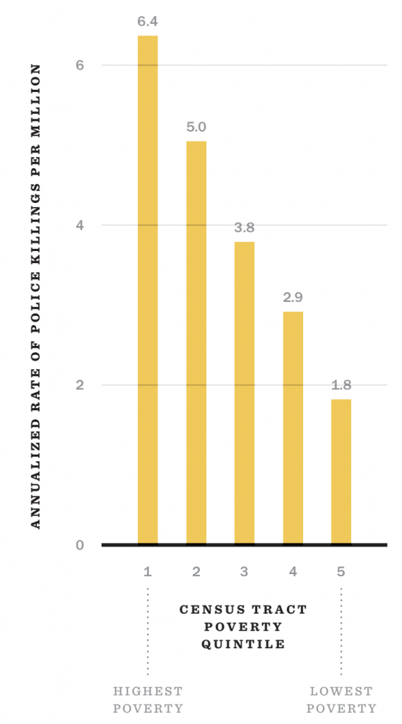
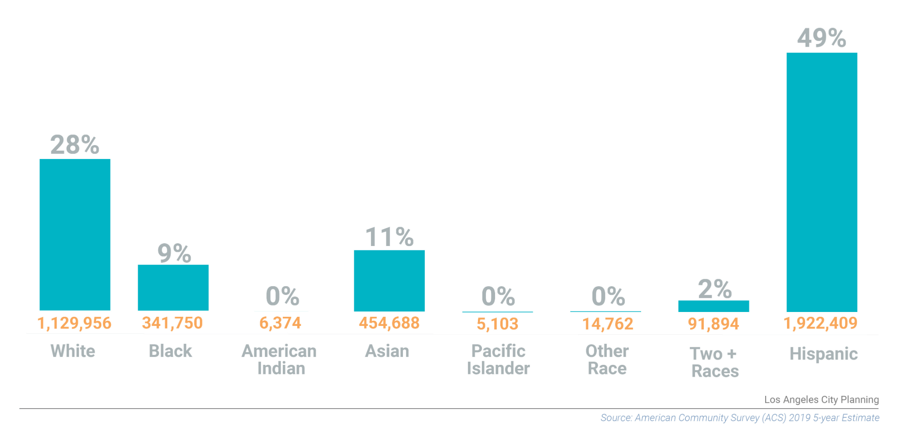
Los Angeles is one of the most diverse cities in the USA. Typical races included in demographic surveys include Asian or Asian American, Black or African American, Native American, Alaskan Native or Indigenous, Native Hawaiian or Pacific Islander, White, Two or more races, and LatinX/Hispanic are typically listed as ethnicity options. Care should be taken to include additional racial and ethnic groups that are not typically included in demographic studies based on community impact. For example, MENA populations (Middle Eastern or North African) should be included, though that ethnicity is not yet recognized on the US census. Being conscious of the racial makeup of stakeholders engaging with the process will be very important. In 2020, LA County Jails were 54% LatinX, 30% Black or African American, and 13% White. (Hare & Rose, 2020). This is concerning considering only about 9% of the LA population is Black or African American, meaning that the population of incarcerated Black Angelenos is over 3 times higher than it should be compared to the overall population, and the population of incarcerated White Angelenos is less than half of what it should be compared to the overall population. Care should also be taken to include Angelenos who are immigrants (documented and undocumented), refugees, and bilingual people or people who do not speak English.
LA County Racial Distribution

Class
Poor people often have less than high school education, housing instability, public or substandard housing, homelessness, need for public assistance, frequent involuntary moves, exploitative/high risk employment, chronic unmet basic needs. Poor people are disproportionately people of color, women, and children.
Working class people often have limited access to education beyond high school , low/ negative net worth, rental housing or modest homeownership, few employment options, and supervised wage jobs. Working class people are majority white, but are disproportionately people of color and women when compared with the composition of the whole population
Middle class people are often salaried professionals, have gone to 4 years of college or more, have secure homeownership or are renters by choice, have more control over the hours and the methods of work and more economic security than working-class people, but no way to pay the bills without working.
Owning class people have enough assets, either individually or family owned, so that paid work is not necessary, have access to education as well as luxuries like travel, multiple homes, property, etc and often expect a large inheritance. (White People 4 Black Lives, 2020).
People in every class will be affected by this decision. Research shows that socioeconomic status is closely linked to police brutality; the country’s highest poverty areas experience 3.5 times the police killing rate of the lowest poverty areas (Feldman, 2020). Policing is historically and inherently tied to protecting capital, whether that be serving as security outside a business or home, returning stolen goods, or ensuring those responsible for producing goods were doing so (i.e. enslaved or formerly enslaved people in the South and low-wage workers, often immigrants, in the North). Today, this perceived responsibility of the police persists, and people from all classes, many middle and owning class residents in particular, are often concerned about the effect that abolition could have on the preservation of their property or capital today. Thus we must consider people from all socioeconomic backgrounds in this public engagement process.

Housing status
The 2020 Greater Los Angeles homeless count completed in January 2020 showed a 12.7% rise in homelessness, with 66,436 people in LA county experiencing homelessness when the count was conducted in January 2020, before the onset of the COVID19 pandemic and subsequent city lockdown (Los Angeles Homeless Services Authority, 2020). Los Angeles Homeless Services Authority reports that homelessness is driven by systemic racism, income inequality, and inadequate housing supply, noting a housing shortage of 509,000 units in 2020. Unfortunately, that also means that unhoused people in Los Angeles are more likely to experience violence at the hands of police. According to the LA Times, “more than one out of three times that a LA police officer used force in recent months involved a person experiencing homelessness” (Miller, 2020), which clearly demonstrates that unhoused Angelenos are valuable stakeholders in the process to engage the public in reimagining public safety alternatives. The needs of renters and homeowners should also be addressed.

Incarceration Status
The LA County jail system is the largest of the United States’ 3096 county jail jurisdictions, holding approximately 2% of the country’s incarcerated population (Hare & Rose, 2020). In addition to monitoring inmates at the 7 county jails, LASD deputies also patrol their regions under the guise of enforcing the law and keeping the peace. When an arrest is made, there is a 26% chance that the person arrested will end up in a county jail, which is a decrease from 37% in 2019 (Hare & Rose, 2020). Angelenos who have been arrested or imprisoned will be key stakeholders in our process because of their first hand experience with LASD, and the critical role their involvement with the system plays in reimagining a more effective, equitable public safety system.
The families and loved ones of incarcerated and formerly incarcerated individuals should also be considered in this process. In December 2020, Commissioner Robert Bonner put forth a motion for the Los Angeles County Sheriff’s Department to develop a policy regarding the treatment of family members to those who have been killed by Use of Force by LASD deputies, forbidding harassment and encouraging respect. The motion came following testimonials from relatives of people killed by LASD deputies detailing how officers continue to harass and intimidate them following the loss of their loved ones (Tchekmedyian, 2019).

People living with disabilities
Disabled individuals are often left out of discussions regarding solutions, but when it comes to abolition, they are important stakeholders. When considering that more than 40 percent of unhoused people in the United States also have a disability along with information regarding high levels of violence experienced by unhoused people, it becomes clear that people with disabilities are impacted by police misconduct. Further, The LA County Jail jurisdiction also functions as one of the largest mental health institutions in the country, with 38% of the inmate population suffering from mental illness (Hare & Rose, 2020).

The People of Compton
Although we are hoping to reach out to everyone impacted by this decision the project team has identified six core groups of stakeholders who represent a diverse cross section of people. These six stakeholders groups are the People of Compton, Public Safety Professionals, Government / Municipal Agencies, Community Anchors, Activist Groups, and Artist / Influencers. We believe that these groups provide a fair representation of the community and its interest. Although the overall level of impact / influence can vary between categories it is our hope to work with these groups in various capacities from basic outreach to creating meaningful partnerships that involve them in the planning and implementation of this process. We have identified some key stakeholders and highlighted some of their potential contributions as well as a list of potential barriers and mitigating strategies. For more information regarding individual stakeholder values, contributions, and possible threats to the project please refer to the attached Stakeholder Matrix. For more information on the demographic information that informed the core team’s Compton-specific approach, please refer to the attached demographic summary.

Compton Students and Parents
There are nearly 24,000 students in Compton School District’s elementary, Middle and High Schools. In addition, there are two higher learning institutions in or near Compton – namely Compton Community College and California State University Dominguez Hills. This category represents the student bodies, as well as their parents.
Students of all ages are the future, and it is imperative that they, as well as their parents, are an integral part of the Abolish LASD process. Although not all students actually live in the City of Compton, this constituent group, especially considering their parents, represents more than half of the city’s population. In addition, the two higher learning institutions have a combined attendance of nearly 24,000. This group’s participation in the entire process is essential to succeeding not just in Inform, but subsequent phases as well.
As with all groups of stakeholders, there are certain issues to consider for this group. First, the material needs to be age appropriate. Considering the age range of the K-12. Secondly, considering that about 2/3 of Compton’s population are either Hispanic or African American, their past experiences with LASD and police in general will play a major role in not just their participation, but the stand they will take – supportive or resistant. The parents of the city’s student body is also a major stakeholder group which will certainly consider their children’s safety as a top priority. This concern might cause them to initially resist changes until they are assured that the new public safety entity will safeguards the children. The final segment of this constituent group are the college and university students, many of whom have taken an active role in the Abolish LASD movement. This group can play a crucial role in all phases of the process, starting with the Inform phase. Many of the methods, such as neighborhood canvassing and on-line videos and e-notifications, can be generated, moderated, and distributed by this tech-savvy constituent group. Furthermore, the existing notification systems within the School District can be utilized to keep all parents informed of all meetings and other events. Kiosks and booths – conveniently located and staffed within school hours, will ensure that parents with language or technological barriers are able to speak to volunteers in person and to be encouraged to participate with their unique perspectives.
City of Compton Educators
Compton School District employs roughly about a thousand teachers. Although there are no definitive statistics on how many of these teachers live in the city boundaries, it is safe to assume that their impact goes beyond being residents of Compton. There are also higher learning institutions in the community such as Compton Community College and Cal State Dominguez Hills which contributes to a greater availability of and access to educators. This is an important factor because as a matter of strategy, educators are crucial in informing the public, through their teaching and their regular contact with students and parents alike. As such, they will be utilized to spread the word and to encourage public participation from all sectors. Another key role for this group of constituents is that they have both access to lower-income communities, and have less of a language or technological barriers, so they can bridge the gap for those under privileged and marginalized communities.
As far as the concerns for this group, safety of their schools and students is a key factor which should be addressed upfront. This group should be given the assurance through factual information, that the new vision for Public Safety will completely ensure the safety and security of all community members. It is also safe to assume that this group will be homeowners, possibly within the city of Compton. In that role their concern might be to prevent any loss of property values, and to make sure their homes are safe, and their neighborhoods are crime-free.
In addition to the methods of engagement listed in the matrix, this group can be recruited to provide on-line, and in-person talks to parents and other members of the community. Their standing as educators is a major plus in terms of the credibility of the message, as well as the movement.

City of Compton Homeowners
As of 2020, the City of Compton has 24,590 Housing Units. Approximately 55% of these dwellings are owner occupied. Basic math will show that this group of constituents represent more than half of Compton’s population, albeit, overlapping with some of the other stakeholder groups. Historically, owning a home has been the foundation of American wealth, and the home has been most families' single most valuable possession. As such, homeowners are very protective of the value of their houses, and typically behave and vote based on self-interest. This is at times in direct contrast with their roles in their respective community. For example, a Compton resident might be an educator and an advocate of Abolish LASD, but as a homeowner concerned about their property value, they might take a more conservative stance, in respect to Abolish LASD. Once again, our approach with this group will be to be completely transparent in our message and to try to reach them by various means, including in-person neighborhood canvassing, distribution flyers, neighborhood town-halls, Conversation Cafes and focus groups.

Public Safety Professionals

Los Angeles Sheriff's department (LASD) / Compton Station
The Los Angeles County Sheriff’s Department was founded in 1850, and as the first professional police force in the Los Angeles area in a time recently after the abolition of slavery, where minorities of all kinds were demonized, and immigrants of color suffered extreme prejudices it would have been easy to predict the tumultuous and corrupt history this agency would produce over the next 100 years.
To further exacerbate the behavior, corruption and disposition of the LASD it was joined by an all-volunteer, and all white organization, the Los Angeles-specific Los Angeles Rangers, who came into inception in 1853 to supplement the LASD. As the city of Los Angeles grew so did its Sheriff's department adding yet another racist and reckless volunteer group known as the Los Angeles City Guards and over the next hundred years as it morphed and modified itself the LASD became the largest sheriff's department in the world, employing nearly 12,000 law enforcement officers and nearly 10,000 support staff.
The LASD has three primary responsibilities which have been to patrol and police more than 153 communities throughout Los Angeles County and at least 42 cities as well. The LASD also provides transportation of inmates, courthouse security within the LA County jail system and for the court system. The Sheriff’s Department also hires its services out to various quasi municipal agencies such as the Los Angeles Metropolitan Transportation Authority and multiple local colleges and public facilities. Lastly, the Sheriff's Department performs professional services such as laboratory research and testing, homicide investigation and police training throughout the county.
Unfortunately, the LASD has a long and storied history of racial profiling, police brutality, police corruption, and other misconduct and as a result poses a severe threat to the issue of abolition. Based on its history the LASD would most certainly not only pose a threat to our informational process but could possibly revert to intimidation or harassment of those involved in distributing any information associated with the abolition effort. It is safe to assume that the LASD would make every effort to disrupt if not destroy the process of abolition.
Consideration of a partnership with organizations like the Re-Imagine L.A. County coalition or Black Lives Matter LA would not only help raise the profile of the effort but could also help ensure the safety of members of the abolition movement by joining forces with the more than 100 local racial and criminal justice organizations such as Black Lives Matter Los Angeles who have been at the forefront of the successful organizing effort to stop LA County’s $2.2 billion jail expansion plan through a 2019 Engagement Strategy.
Public Safety Partnership and Violence Reduction Network
In 2000, the City of Compton disbanded its police department in response to widespread corruption and decided that it would forgo the provision of law enforcement resources from the Los Angeles Sheriff’s Department. However, in 2015 the Public Safety Partnership began to provide the Compton Sheriff’s Department with consulting services and began to provide access to broader law enforcement resources in cooperation with a strategy and plan to curb violent crime which was heavily supported at the federal level by the Department of Justice. This Justice Department cooperation is intended to bring to bear myriad resources to ensure that cities like Compton are able to manage and overcome extreme violence. This cooperative effort is viewed as a more effective and efficient way to provide necessary resources, training and exposure to proven policing best practices throughout the United States.
In conjunction with this effort Compton was also selected to join the Violence Reduction Network (VRN) and together with the participation of LASD has substantially reduced crime in the city of Compton. As a result of the activity of both the National Public Safety Network and Violence Reduction Network the LASD has again established a foothold in the city of Compton using the increased presence of federal law enforcement to their advantage. Due to the perception of law enforcement that their efforts have largely been positive, these agencies will likely campaign against the abolition movement formally and informally. A significant impediment to Abolition could arise from the strong federal support and alignment to and with the LA County Sheriff's department.
We should anticipate the use of tactics such as negative campaigning to counter the positive message being communicated by the abolitionist movement. And while these agencies are not likely to use the same unlawful, intimidating or unacceptable tactics that members of the LA Sheriff's Department may employ, their resources, network and level of influence on a local and national level could threaten to derail the entire process. In this scenario our outreach and engagement may be better served by going through an intermediary that holds similar power, status and standing in the community or on a political stage that would insulate them from the kinds of attacks and vitriol the issue of abolition is likely to encourage. Various methods of engagement should be used in this scenario however all methods of engagement should ensure some level of anonymity and provide some level of discretion for those individuals responsible for executing outreach and communication.
Compton City Attorney
Damon M. Brown is the City Attorney and Chief Legal officer for the City of Compton. In his role Mr. Brown is responsible for a team of attorneys along with supporting staff that represent the City Council and all City officers in any matter pertaining to the law particularly where their offices and/or positions are concerned. Mr. Brown is highly respected in the legal community and currently serves on the Board of Trustees of the Los Angeles County Bar Association. Coincidentally, Damon Brown has also previously initiated a lawsuit against the LASD on behalf of Compton and is a likely advocate for abolition.
Coincidentally, Damon Brown and others have called on the state attorney general’s office and the U.S. Department of Justice to investigate the LASD, in particular the Compton sheriff’s station. In addition, Damon Brown has filed suit against the LASD alleging fraud and under no circumstances appears to be an advocate of the Compton Station having accused the station of tolerating everything from gang and clique activity, corruption, brutality and fraud. As mentioned above a high level of coordination and communication is recommended where Damon brown and the City Attorney’s office is concerned

Sheriff Civilian Oversight Commission
The 9-member Civilian Oversight Commission was established by a BOS vote in January 2016, with the goal of improving transparency and accountability in regards to the LA Sheriff’s Department through community engagement (Civilian Oversight Commission, 2021). Their proximity to the LASD and the role the Commission plays in engaging the community and relaying concerns makes the group an important stakeholder with the potential to offer many insights regarding shortcomings of the LASD and common complaints from the public.

The Union
The union is an independent labor group that bargains on behalf of the sheriff's department, and Los Angeles has two: the Association for Los Angeles Deputy Sheriffs (ALADS) and the Los Angeles Sheriff’s Professional Association (LASPA). The abolition of the sheriff's department may reduce the number of members or increase the number of members depending on labor groups' decision to collectively bargain with the County. It should be anticipated that the union will not go away, will advocate for and on behalf of law enforcement and any new roles that may come from the abolition of the sheriff's department and new enforcement strategies. Due to their large influence and proximity to the topic of public safety, the Sheriff’s unions are stakeholders who will likely be adversaries to abolition unless approached appropriately and early in the process, without being given disproportionate power/sway over the public engagement process or recommendations produced as a result.

Fire Department / EMS
The Los Angeles Fire Department (LAFD) is considered a stakeholder in addition to Emergency Medical Services due to the role they both play in ensuring different aspects of public safety. Additionally, some inmates at LA County Jails are trained through the Fire Camp Training Program to fight wildfires at California Department of Corrections and Rehabilitation Camps (Hare & Rose, 2020). This close relationship between people who learned to fight fires as a result of being arrested and incarcerated by the LASD reenforces the significance of LAFD as a stakeholder in this process.

Non-Traditional Public Safety Professionals
Los Angeles already has multiple organizations that provide different services related to public safety. These include housing services to assist the unhoused (HOME, LAHSA, SELAH), mental health services (Access Crisis Hotline, Suicide Prevention Hotline), domestic violence and sexual assault support (Jenesse Center Inc, Jewish Family Services, Peace over Violence, YWCA), LGBTQ+ support (LA LGBTQ+ Center, YES), youth (CA Coalition for Youth, Children of the Night), elder assistance (WISE and Health Aging, LA County Adult Protective Services), crime, ans substance abuse. Representatives from programs in other cities that have proven successful (like CAHOOTS in Eugene, OR) could also be helpful consults. People and organizations who are currently providing these services should be considered key stakeholders, as their work may be expanded upon or increased as a result of abolition, and they are likely to have excellent insights regarding the current gaps in law enforcement services in addition to resources that alternatives to policing are lacking in order to be more successful. Further, the abolition of the sheriff's department could potentially lead to more contracted security at local businesses, and so local security companies should also be considered in this process.

Government / Municipal Agencies
A variety of government and municipal agencies from the BOS to communities that contract with the sheriff's department will have to address the issue of abolition. Their influence and decision will be heavily determined by the influence of their constituents and the political points of view. The LASD contracts with over 40 cities in LA County in addition to being responsible for unincorporated areas of the county and cities that do not have their own police force, which included Compton. Legislative representatives from those cities should be included in this process. Other political figures who should be included in this process include the LA County District Attorney Gascon, Chief Executive Officer Davensport, and Mayor Garcetti, to name a few.

Compton Mayor Emma Sharif
Elected as Mayor June 1, 2021. A resident of Compton for many and working in the community for over 20 years as public-school teacher, and a youth development director in Compton. In 2001, Emma was appointed to the Compton Unified School District (CUSD) Board of Trustees, filling a Board vacancy. In 2003, Emma successfully ran for the full term and served as Trustee of CUSD Board of Directors for fourteen years. In 2015, Emma ran a successful campaign for Compton City Council District 4.Emma Sharif holds a Bachelor’s Degree in Political Science/Sociology and a Masters Degree in Public Administration. Emma also holds membership with the following organizations: National Council of Negro Women (NCNW), National Women’s Political Caucus (NWPC), Martin Luther King Democratic Club (MLK), New Frontier Democratic Club (NFDC), and Progressive Democratic Club. As the Mayor of the City of Compton, many of the organizations, elected leaders, and other stakeholders will look to the mayor to understand the direction of the city. Recently elected as Mayor she will be in office for the next four years. It’s anticipated that as a democrat and an African American woman she will elect to support the abolition of the Los Angeles County Sheriff's Department and look to support the movement and transition.

Dist. 2 Council Member Isaac Galvan
After graduating from local schools and studying at Santa Monica College, Councilman Galvan opened his own small graphics and printing business. In 2013, he became the youngest and the first Latino councilman in Compton’s 125 year history. In 2016, he also became Compton’s first Latino Mayor Pro Tem. He’s worked with Compton natives, such as R&B rapper Kendrick Lamar, NBA All Star DeMar DeRozan, YG, and DJ Quik, and other celebrities such as MC Magic, Oscar De La Hoya and Hilary Clinton to take an active role in giving back to the City of Compton by inviting residents to special events. As a Hispanic elected member, Councilmen Galvan will offer representation of the community and can help bridge our message to not only the Hispanic community, but the immigrant and Spanish speaking community. Councilmen Galvan has also demonstrated that he can collaborate and work with celebrities and influencers to achieve his goals, which can help our goal to educate and influence his constituents and the Hispanic community as a whole.

Captain Latonya Clark
In October of 2019, Captain La Tonya R. Clark was selected by the Compton City Council as the new Captain of the Compton Station to oversee law enforcement services. Captain Clark is the 13th captain selected via Sheriff Villanueva’s Captain selection process. She has been a member of the Los Angeles County Sheriff’s Department since 1990. Captain Clark will provide our initiative a balance as a member of the community and law enforcement officer. Her ethnicity and gender will also offer the community a perspective that others could relate to, rather than having a white male. It’s anticipated that she will look to support both sworn officers and a continued law enforcement presence in the community which will offer our engagement a balance and demonstrate that support of this transition comes from both the left and right side of the spectrum.

Compton Chamber of Commerce
The chamber of commerce is a membership organization that advocates on behalf of local businesses. It is backed by a board that is composed of businesspeople from the local community. The chamber represents a resource, advocate, and connector for business. It’s anticipated that because of the diversity of the Chamber of Commerce we will find that many of the members will have varying stances when it comes to the abolition of the Los Angeles County Sheriff's Department. However, we also anticipate that a common thread will be to seek a safe transition and an environment that will be supportive and responsive to the needs of businesses in the community. Moving forward their input will be important as well as their ability to use their resources and platforms to amplify our message. They will offer us a partnership to host events and participate in our events to deliver our message and celebrate the community.

Community Anchors

Community Service Providers
The City of Compton is an area of LA County well documented by its long history of hardship and strife. As a result there are a growing number of community organizations that work passionately to provide services focused on improving the quality of life for many of the city’s most disadvantaged and vulnerable populations. Poverty and wealth inequality, lower than average educational attainment, broken family dynamics and uncertain immigration status are among the many struggles that face the residents of Compton. These are some of the primary focuses of the community service providers that we’ve identified as stakeholders in our engagement plan because these are many of the same conditions that have contributed to the unrest and distrust between civilians and law enforcement that ultimately lead to the breaking point for our public safety system. Community service providers are sources of hope and support for members of a community and for the City of Compton, these can tend to be highly trusted foundational building blocks within a person's life.
We seek to establish connections with many of Compton’s most impactful community service providers who we’ve identified as having the highest levels of reach and influence. The Compton Initiative is an example of such an organization whose mission is to restore Compton by beautifying homes, schools and churches. On four occasions each year the organization brings together volunteers from the faith community, non-profit sector, and mission driven corporations to transform neighborhoods by simply painting people’s homes. Because of the tremendous value the organization delivers to the people that it serves, it has amassed an incredible database of resident contact information who are now members on their waiting list. The Compton Initiative could be an incredible resource in terms of outreach and messaging. The Compton Advocates Coalition is another example of a potential outreach partner who has a well established membership base with a mission of empowering the residents of Compton by providing connection to resources, promoting unity, encouraging action-oriented solutions, and cultivating the desire for knowledge.

Religious Groups
Religious affiliation and membership to a congregation can be one of the largest sources of influence among groups of people within a community and 53.4% of people living in Compton identify themselves as being religious. This is notably higher than the 45.8% of people living in the State of California who claim the same thing. Compton has a visibly high number of churches per capita and there is a church in particular that has a high degree of significance in our engagement strategy. Faith Inspirational Church is founded and pastored by a man named Rafer Owens who also happens to be a Deputy Sheriff in the LA County Sheriff's Department. We feel that starting a dialogue early with Pastor Owens can be crucial to our awareness campaign. As a Christian church leader, an African American, and a Deputy Sheriff, Pastor Owens has a uniquely intimate connection to the outcome of the Abolition movement and while we don’t know which side of the fence he will stand on during this process, we do know that there will be a lot of eyes watching his response. For this reason, we assign Faith Inspirational Church with a high degree of importance as a stakeholder in our community engagement plan based upon the level of impact and influence that the church pastor has within the City of Compton.

Local Gangs
The LAPD reports that Los Angeles County is the “gang capital” of the country, with over 45000 people involved in over 450 active gangs, some of which have existed for over 50 years (Los Angeles Police Department, 2021). Gang members come from all demographics and can exert great influence over the communities they are rooted in. There is a perception that a reduction law enforcement officers could potentially embolden gangs and criminals to participate in more acts of violence and or crime such as: homicides, drug sales, kidnapping, human trafficking, prostitution, extortion, and more. However, research suggests that gangs also provide essential services to communities where public services are scarce or non-existent. In his book, Gang Leader For a Day, sociologist Sudhir Venkatesh
“does unravel a complex, intertwined system of political and economic relationships that make the housing project run in the near-total absence of city services. The police and ambulance crews in particular regard Robert Taylor as a no-go area. In their stead, local warlords and quasi-political figures… hold sway.” (Grimes, 2008)
This complex dynamic demonstrates how collaborating with local gangs could be useful in imagining the future of public safety. Given recent revelations regarding LASD deputy gangs, perhaps “real” gang members could help us better understand that dynamic and prevent it from manifesting in proposed alternatives. As such, there are multiple community organizations operating within the City of Compton that are actively working to provide job training, and support to formerly gang-involved and previously incarcerated people, allowing them to redirect their lives and become contributing members of the community. Among these, we have identified Homeboy Industries as a key stakeholder to our community engagement plan. While Homeboy Industries is not headquartered in Compton, the organization’s reach, expertise and level of influence in this particular area is of crucial importance to our outreach efforts. Getting the attention and then earning the trust of people that belong to this focus group is a delicate matter, so we seek to partner with organizations that have built a reputation on a foundation of support. We are excited at the opportunity to gain the perspective of these individuals and know that without the help of partnering organizations, we are unlikely to accomplish this at the level that is necessary.

School Districts
School districts are one of the most important stakeholders, namely Los Angeles Unified School District (LAUSD). They shape the mind, body, and soul of our youth. It is where millions of students gather to learn and develop. School districts rely on the patrol of law enforcement to ensure that students follow school rules and policies, are safe, and are not involved in illegal activities. School districts also rely on law enforcement to support them with on campus support when there are acts of violence or possession of drugs on school grounds. They also respond when there are acts of violence by individuals or groups, other than students. It is likely that institutions themselves may be adverse to abolition, however a student led group called Students Deserve has begun a powerful and successful campaign in 2020 that resulted in the removal of police from high school campuses once school resumes in person again, in addition to $25 million divested from school police and an extra $13 million invested into Black student success and support services for staff and students (Students Deserve, 2021). This strengthens the importance of schools as stakeholders in this process.

Hospitals
LASD contracts with over 200 medical care facilities, hospitals, and clinics, making them stakeholders in the process of reimagining public safety, as well. Hospitals have recently received attention from abolitionists in Los Angeles after a patient suffering a psychiatric crisis at Harbor-UCLA was shot seven times by an on-duty deputy, putting him in critical condition (Tchekmedyian, 2020). Hospitals have good reason to be concerned with the safety and well-being of their patients, so they should be involved in the process of reimagining how that can and should be provided to them.

Activist groups
There are many activist groups working towards collective liberation through a variety of venues, including abolition, budget reformation, social justice, racial justice, disability justice, LGBTQIA2S rights, environmental justice, and more. All of these activist groups have goals and agendas — some of which are related, some that are not — and although not directly tied to any political group, they can share similar perspectives and or influence political groups based on their rhetoric. These groups are important stakeholders because they have been immersed in their communities within their respective area of interest or expertise, and have a high level of awareness regarding the needs of the people they fight for or represent. Abolitionist groups like Critical Resistance LA have fought for years and years to develop and incrementally implement alternatives to policing and incarceration in favor of community based public safety solutions, so they have a wealth of knowledge and experience to share.

Black Lives Matter Los Angeles
Black Lives Matter was founded as a hashtag and a movement by three Black organizers, Alicia Garza, Patrisse Cullors, and Opal Tometi in 2013 in response to the acquittal of 17-year old Trayvon Martin’s killer, George Zimmerman. The first chapter in the now-global Black Lives Matter network, BLM LA works to advance freedom for Black people by responding to crises in the Black community, dismantling systems that keep Black people oppressed, envisioning and building new structures, and by offering spaces of Black love. As one of the larger BLM chapters, BLM LA will likely be heavily impacted by the process of informing the public about the history and implications of policing, in addition to the next phase of reimagining what public safety should look like in Compton and Los Angeles. They will also have a high level of influence over the community and the success of the project, as BLM leaders are often looked to during high-profile social justice reform campaigns. It is important that we inform BLM leaders of our process and intentions proactively, and partner with them to ensure we produce accurate and aligned material to the public in order to ensure authenticity and garner their approval and support.
The Black Lives Matter End Police Associations (EPA) coalition works to remove police from the labor movement (unions) by ending police associations, remove police from local neighborhoods to reduce the harm they cause to communities, and advocate for resources that help communities thrive. The public engagement process will likely have a high impact on the many members of this coalition, as they have been working for years to achieve their goal of ending police associations, which is an essential part of abolition related to defunding the police. Though not as widely known as BLM, the EPA coalition has high influence due to being part of BLMLA and its network of involved organizations. It is important that we partner with this group to understand the role that police associations play in Los Angeles and what work has been done thus far to dismantle them, and communicate that information to the public in a meaningful way. We can also partner with EPA to spread awareness about our engagement plan with coalition members and their wider circles.

Justice LA and LA Alternatives to Incarceration Initiative
Justice LA is a coalition that works to stop jail expansion and divest funds from incarceration for investment in community-based systems of care and other alternatives to incarceration and policing. They focus on an intersectional community-based approach that aims to uplift those that are most heavily impacted by incarceration in LA. Justice LA will be highly impacted by this process, as they are concerned with developing and investing alternatives to policing. They will also have a high influence on the success of the project and the community’s acceptance of the process. Justice LA is a vital partner because they can use their network to increase awareness of the public engagement plan and process in addition to contributing essential information and expertise as we move forward informing the public about the many facets of abolition.
Justice LA led the initial LA Alternatives to Incarceration Workgroup report. The work group was established by the LA Board of Supervisors in 2019 with the purpose of drafting a plan for a more effective justice system in Los Angeles County. The plan was completed and the five overarching strategies adopted by the BOS in March, 2020, after which the LA County Alternatives to Incarceration (ATI) Unit was established. The new ATI unit then began working under the direction of Songhai Armstead to formulate a strategic plan for using the human-focused, “care first, jails last” approach in LA county. This initiative will be greatly impacted by the proposed public engagement plan, as it focuses on strengthening alternatives to public safety and incarceration. It also has a heavy influence on the project’s success through relevant political figures, namely the BOS. It will be important to work with the ATI group to understand the work that has been done to move LA towards a “care first” future, as well as the obstacles that have come up from a political or legislative perspective. As this group is highly involved with the BOS, it will be important to maintain a positive working relationship with ATI leaders and work together to execute this engagement plan and create sustainable, substantial changes to the public safety system in LA.

Californians United for a Responsible Budget (CURB)
CURB is a coalition of 70 grassroots organizations across California that aims to amplify the work of community leaders on issues of sentencing reform and carceral conditions, reduce the number of people in prisons and jails, and shift public funds spent on incarceration and policing to human resources. CURB is the parent organization of the local workgroup LA No More Jails, which works to stop LA’s proposed $3.5 billion jail plan. CURB will be able to shed light on the finances associated with policing and incarceration in addition to highlighting how those funds could be used with greater efficiency and integrity to improve public safety in ways that do not involve police or LASD deputies. CURB will be impacted by this public engagement process due to the nature of their work and the rich network of organizations they work in solidarity with. They will also have a high level of influence over the project through said network and connections in the abolitionist community across the state. CURB is an important organization to partner with to gain reliable information about the LA budget, the financial ramifications and benefits of abolition, and what responsible city spending looks like at the municipal level. They should be involved during the pre-engagement phase for educational and outreach purposes, as they will likely be able to help spread awareness of this public engagement campaign in their network.

LA CAN
LA CAN fights back against oppression by organizing and empowering Los Angeles residents to work together to change the relationships of power that affect the LA community. LA CAN aims to create and exemplify an organization model that eradicates the race, class, and gender barriers that often prevent communities from realizing and building power, and ultimately eradicate violence used against and within communities to maintain the existing state of affairs. LA CAN has over 20 years of experience building community capacity to participate in work that will elicit change and contribute to the fight for social justice. As such, they will have a high influence on this project through their network, knowledge, and community ties. LA CAN is an important partner because they understand the challenges associated with abolition and social justice work and can provide insight into evoking change in Los Angeles. By partnering with LA CAN, we ensure that the engagement process will encourage and enable residents to participate, and partnership may aid in building trust with community members. As such, they should be involved in the process during the engagement phase for the purpose of consultation and outreach.

Social Justice Learning Institute
The Social Justice Learning Institute (SJLI) is dedicated to improving the education, health, and well being of youth and communities of color by empowering them to enact social change through research, training, and community mobilization. Education, access to resources, and equitable policies are essential to creating a thriving community, and SJLI uses those three avenues to build community capacity for participation in achieving social justice. Given this understanding and the history of successful initiatives led by SJLI in LA communities, the Social Justice Learning Institute is a crucial partner to this engagement process. As we aim to empower community members through education and increased access to resources that will enable them to participate in reimagining the future of public safety in LA, a partnership with SJLI will allow us to collaborate on both approach and material to ensure the process is accessible and effective. In addition, they may be able to contribute to spreading awareness through their network.

Influencers / Local Artists
In order for the project group to have a successful engagement process we have to ensure that we not only understand the culture of Compton but do our best to integrate ourselves into it as much as we can. This process requires a lot from the community and we would hate to be seen as outsiders coming into a community without respecting the existing culture that makes Compton what it is. The city of Compton has been and continues to be the home of incredibly talented individuals with diverse backgrounds and different crafts. As such we wanted this process to be a celebration of the talent that Compton houses. By undertaking this process the City of Compton will be put up to a national spotlight and we would like to use that as an opportunity to showcase the talent and resilience of Compton natives.

Compton Art Walk
The Compton Art Walk is an organization that aims to provide a forum for Los Angeles artists and entrepreneurs to network and showcase their talents. Their mission is to create a platform through authentic experiences that allow former, current, and future residents to support and demonstrate pride in their city's rich musical and artistic heritage. Many members of the CAW leadership team are natives of Compton, and we believe that their experiences and connections to other local artists could help us craft a creative direction that celebrates and incorporates Compton's heritage. The members of this organization are residents of Compton first. As such many of them value-creating opportunities for the community. If we partner with them, we believe that we can commission local artists to create pieces that capture this experience. Many people of Compton have been negatively affected by the current policing system and use art as a way to express themselves. We believe that these works of art could go a long way if incorporated in our flyers, presentations, and community events. It is also a great way to constantly highlight local talent throughout the engagement process.

The Compton Cowboys
The Compton Cowboys is a community that has been actively trying since 1988 to push a narrative that there is more to Compton than what people typically associate it with through unity and a connection to horses. They believe that a connection to animals shows people that there are other options in their community. Many of their members have been affected by gang violence, but have turned that energy into love and compassion for rescued horses. The group fights against Compton's negativity, and we believe that they are an integral part of any movement that addresses community policing. In 2020 alone, they led a ride for the Black Lives Matter movement that drew thousands of people. We hope that by partnering with them during the pre-engagement phase, we can form a relationship with them and work with the group to spread awareness about the scheduled events. The group also does small workshops and performances with the horses, and as such, they could be a huge draw for the community celebration event.

Discussion of potential barriers and suggestions for mitigation
A public participation plan isn’t a ‘Field of Dreams' scenario where if you build it, they will come, and like a chartered fishing excursion, a high-end boat and expensive equipment provides no guarantee that you’ll come home with a prize catch. We will explore various possible barriers to participation and explain efforts we will use to mitigate each one.

Ineffective Facilitation
First and foremost, we understand the importance of our role as facilitator and like the root of the word defines, we embrace that our job is to simplify the effort of our stakeholder participants. The topic our audience is being informed about is not an easy one to keep as a one-way dialogue, so as facilitator, we will use a variety of communication methods including the use of video to ensure that events are quick moving and free flowing so that people remain engaged, focused, and generally at ease. We will call on presenters and commentators of the utmost relevance to the topic, by enlisting Holly Mitchell the 2nd District representative of the BOS along with the respective City Council Member active in the District where the meetings will be held.

Awareness and Accessibility of Information
As we embark on this mission we will put extreme emphasis on the first and most crucial step of the process, which is to ensure that all stakeholders are fully aware and have full access to the information and opportunity that is being presented. This is a step that will involve extensive outreach and marketing across every form of communication available in order to reach people in all of Compton’s hard to reach places. As noted in our stakeholder analysis, Compton is a City that connects and relies deeply on its community organizations so we will seek the support and assistance of specific groups to help further our reach and provide associated trust based on the source of information.

Lack of convenience - Time and Location
We understand that not everyone operates on the same schedule or routine. When informing on a topic of this magnitude that impacts everyone, we will select a variety of times and locations for stakeholder engagement meetings that ensure equal opportunity for participation, whether a person works a ‘9-to-5’, an overnight or weekend schedule, has four kids with extra curricular activities, is elderly, or is disadvantaged by transportation constraints. And further, we will deploy an on-demand video library on our program website, as well as social media portals, to enable those who can’t be physically present at our meetings to still experience and consume the information that has been presented.

Language and Cultural Norms
Similar to routine and schedule, we are intimately aware that not everyone speaks the same language or adheres to the same cultural norms and therefore all of our material, including live presentations will be delivered in both english and spanish. Additionally, we will seek to enlist the support of a trusted third party within all known prevalent culture groups in the City of Compton to assist in our outreach efforts and translation as needed in order to effectively mitigate the language barrier.

Positions versus Interests
As a facilitator to an extremely polarizing topic of discussion such as this, we are highly sensitive to the prospect of differing opinions turning into combative and unproductive confrontation. For this reason, we will spend ample time at the beginning of each public participation meeting enlightening our attendees on the difference between position and interest. We will seek to establish a common goal at the onset of each gathering so that people come to understand that even though their opinion (position) about how this problem should be solved might differ from the person sitting next to them, the underlying value (interest) that their opinion attempts to achieve is actually in line with the people of differing opinions. This is a very delicate process that involves us as the facilitator to broaden perspectives and understanding, by motivating all stakeholders with a shared picture of the future.

Political views
As previously touched upon in positions versus interests, we will be insistent to create an environment of learning to attempt to mitigate the roadblocks that politicization can impose. Improving public safety is a goal that we feel most (potentially all) people can get on board with, so our intent will be to separate the political influence ingrained in our subconscious and demonstrate that there is a human element to this process and discussion that supersedes the candidate each stakeholder voted for.

Biases (conscious and unconscious)
Very similar to political views, we are well experienced with the obstacles of biases and understand that the root of the problem is often that most people aren’t fully aware of the biases they have. We won’t attempt to solve this problem on an individual basis, but we will provide insight into the truth that we are a product of our circumstances and that whether we acknowledge it or not, biases are present within each of us. Our goal will be to respect the community we’re working with and encourage our participants to do the same to the absolute best of their ability.

Cynicism and Distrust
As made apparent by the recent pressure placed on the Board of Supervisors and other government agencies to enact genuine change in Los Angeles, a vast majority of community stakeholders have lost trust in the ‘system’. This is a significant barrier to participation because there is widespread belief that what LA residents think or want doesn’t really matter or won’t impact the ultimate decision made. We know that a large obstacle to the success of this mission is to repair or eradicate much of this cynicism. We will attempt to do this by creating a level of transparency and disclosure that has not been previously seen in any policy making process. The promises we make to the public will be tracked in real time, through continual updates and outreach, and our program will demonstrate true and concurrent cause and effect.
Cynicism and distrust may also be a challenge when working with advocacy groups and social justice driven organizations who have seen firsthand how performative politics and public officials can be, often having worked years to have legislation or reforms passed only to have them upheld half-heartedly or only partially funded. For example, this may happen with Measure J, a revolutionary measure lauded as a first step in defunding the police passed in 2020 that mandated that 10% of local revenue -- $900 million -- be set aside annually for community investment and developing alternatives to incarceration but now faces an $800 million cut. To mitigate this distrust, we plan to engage advocacy groups early on during the public engagement process to understand their work and formulate the best approach for the community. We will be transparent with our process and efforts, accountable when we make mistakes or uncover an oversight.

Citizenship / Disenfranchisement / Disinterest
Many people are excluded from the right to vote and many more are led to complacency based on their belief that their voice doesn’t count. As part of our initial outreach and awareness campaign, we will emphasize and diligently inform the public that this process is not a ballot measure, and that their citizenship status or right to vote is not only unimportant to the conversation, but that it is also not at jeopardy of being questioned. Compton is an area of LA County dominated by a hispanic population and many of the residents are undocumented. Just as much, there is a disproportionate segment of the population that has spent time in the prison system and is documented as a felon. We will be extremely diligent to work with community organizations who specialize in this type of outreach and provision of services to make sure that individuals who fall into these categories are reached and feel safe to take part.

Stakeholder Summary
A project this extensive requires involving a huge number of people at varying levels of capacity for engagement and different phases in understanding of the topic. We hope to welcome these various stakeholder groups into the process of reimagining public safety through a comprehensive informational engagement plan where all members of the community can participate in a way that is meaningful, and by doing so, generate confidence and ownice of the solutions that are ultimately suggested in a later phase of the process leading up to abolition as a result of their participation. Please refer to the Stakeholder Matrix for a more extensive list of key stakeholders.

SECTION 3
Methods, Resource Map, Communications Strategies, Proposed Budget
Public participation gives citizens the opportunity to influence decisions that impact their lives. The decision made by the Los Angeles Board of Supervisors (BOS) to abolish the Los Angeles Sheriff's Department(LASD) will in some way affect the lives of over 10 million people. Given the massive impact of this decision, a multistage public engagement plan has been proposed to ensure that everybody who wants to participate is given the opportunity to do so. In order to formulate our approach in “Informing” the public regarding this change, we have studied several methods and techniques, which we are listing in the following table.

Method | Description | Considerations
Printed Material | · Newsletters  · Letters  · Posters  · Flyers  · Fact Sheets  · Brochures  · Reports | · This method works best for individuals who are less inclined to use social media, especially older and retired citizens.  · This method can serve as a visual reminder as well.  · Letters can be used to show a personal touch and extra care.  · This method can be used to provide basic information and facts regarding the reason for change and/or the engagement.  · This method is less likely to resonate with younger and more tech-savvy constituents.  · Some environmentally conscious citizens might object to the use of paper for this method.  · Cost is an issue here, especially if the change requires multiple printing.  · Another drawback is that there might be a lag time between when the message needs to go out and when the public finally receives the message, due to the prep work and printing cycles.  · Limited to one-way communication
Public Hearings | · A meeting is a coming together of people for a specific purpose.  · Meetings generally have a facilitator who encourages two-way communication, and a recorder who records suggestions and issues that are revealed at the meeting. | · Public meetings should be used as part of a series of engagement events, rather than a stand-alone technique. When used in conjunction with other methods, they can be a valuable way of sharing information and demonstrating openness and transparency.  · Provides an opportunity to relay information, explain processes and gather feedback with a large number of people.  · Can be a good opportunity for people within the community to meet each other and network.  · Large groups and traditional formats may be intimidating for some people and can limit audience participation. Consider incorporating smaller group discussions.  · Public meetings provide a good focal point for media interest in an event, and photos can provide a visual indicator or levels of interest and the range of people who attended.  · Public meetings are often the springboard for a movement or for the establishment of a common-interest group which will continue to act on the issues raised and suggestions made.  · Note that the audience is likely not representative and attendance levels can be low unless people feel deeply connected to the issue and/or make the time to attend. Ensure the meeting place is accessible, as well as providing childcare and food/beverages.
Videos | Preparing informational videos on the subject for the target audience. | · Videos are a great audio/visual tool to inform the public of any change that is being proposed.  · Most video outlets allow for comments and a feedback mechanism to get a sense of what the viewers thought.  · Videos can be paused and replayed to reinforce the informing and comprehension value.  · Videos can be on-demand so the target audience can consume the content at their leisure.  · Videos can be made to personalize the experience.  · Videos may not be the best option for the older population, or those who are not tech-savvy.  · There is a production cost associated with this approach.  · It should be considered that any video which is not prepared professionally or at least tastefully might have the opposite effect.
Tours / Site Visits | Taking the audience on a physical tour of the proposed changes. | · This method is great to provide a guided, in-person audio/visual showing of what change is being proposed and what the new look will be.  · People associate it with the personal nature of this approach.  · Most people believe their eyes more than other senses.  · There might be some cost and risk involved regarding providing transportation, insurance, etc.
Social Media | · Facebook  · Twitter  · LinkedIn  · Instagram  · Snapchat  · Pinterest  · YouTube | · Social media provides almost instantaneous access to masses.  · Most younger citizens and tech-savvy people mostly. communicate through social media.  · The accuracy of content on social media has recently come under scrutiny so your message might lose some legitimacy in the eyes of the audience.  · This method might create a de-facto exclusion of the older and less tech-savvy populace.  · There might be some exposure fatigue in the social media user base, so informing them through this method might not resonate with everyone.
Press/News Outlets | · Community-based  · Local(city/state)  · National | · This method will allow a wider range of audience members to be informed of your message.  · Provide credibility since it is coming from a trusted source.  · There is no/little cost.  · One of the disadvantages is that the outlet retains editing privileges and might directly/indirectly alter your message.  · Use of the media or news outlet might also emphasize undesired polarity since many of today’s outlets are ideologically aligned – real or perceived.  · Limited to one-way communication.
Live Streaming / Live Presentations | Through social media and other means such as Zoom or Jitsi Meet | · Benefitting from the skills of a great presenter/salesperson.  · Providing information in a live setting which allows for questions and follow-up conversation.  · Adds credibility to the presenting body.  · A bad presenter or badly produced presentation might actually have the opposite impact.  · Some citizens might not have access and feel excluded.  · Q&A opportunities.
Panel Discussion | Informing the public through a discussion among a panel of experts and/or informed officials | · The experts and officials are able to inform the public with all the pertinent details.  · These experts and officials tend to give the proceeding a certain amount of credibility.  · The discussion runs the risk of being lopsided, without both sides of the issue being fully vetted.  · The experts might require a fee to appear.  · Due to logistics and costs, the number of these discussions can be very limited.  · Physical presence of the audience might require providing transportation, childcare and food and thus adding to the cost and logistics planning.  · Some of these discussions become emotional and heated and do a disservice to the public.
Exhibits / Boots / Public Displays | Exhibits and kiosks in public places such as malls, convention centers, public places, etc. | · Great visual reminder of the proposed change.  · Allows for self-paced study of the material.  · Making a personal connection with the public through manned booths/kiosks.  · Limited in reaching a large audience.  · Cost associated with renting spaces, labor, printing and production.  · Short attention span of passing public.  · Can gauge the sentiments of the general public.
General Information Channel | Public Information Channels | · Great medium for captive audience.  · Can be repeated multiple times.  · Harder to reach younger target audiences.  · Established credibility.  · Although the local cable providers do not charge for public information broadcasts, there is still the production cost.  · Limited to one-way information
Websites | On official site (.gov or .org) or other trusted on-line platforms | · Complete control over the message.  · Mostly limited to one-way communication.  · Cost of designing and maintaining the page.  · Use of graphics to deliver the message.  · 24/7 access for the public.  · Might exclude older citizens and ones without internet access.

Pre-Engagement Phase
The first phase of this plan seeks to start engagement with the City of Compton. We will be drawing from the “inform” level of participation outlined by the IAP2. This level aims to provide stakeholders with balanced and objective information to assist and prepare them to understand the problem, alternatives, and solutions (IAP2, 2018). Given the massive impact of the decision made by the BOS, the priority of any engagement plan must be to ensure that the community is informed, understands how these decisions will influence their lives, and creates citizen power through education. In this stage, the core project team must identify and implement the right engagement approach to ensure that the community engagement process is inclusive, transparent and fulfills the promise made to the community by the BOS that they will be informed before additional decisions are made.
Arnstein's Ladder is a guide to seeing who has power when important decisions are being made. It has survived for so long because people continue to confront processes that refuse to consider anything beyond the bottom rungs (Arnstein, 1969). However, without first providing an informational foundation, the higher levels of participation could still prove ineffective. By successfully preparing this stage, we hope to equip the public with the tools they need to devise an informed decision that is the best option for their community.
The “inform” phase will be broken down into three different steps, each with its unique action items. The first step is the pre-engagement stage and this is crucial to ensuring the success of the overall project. This will be followed by the engagement stage where we are directly interacting with the public. Finally, the post-engagement stage closes the loop and on the inform phase by allowing the core team to present their findings and allowing the community the opportunity to evaluate the process.
Pre-engagement acts as a foundation for the rest of the process and should therefore be built with longevity in mind. In this phase, there is very little interaction between the team and the community as it requires the creation of materials that the core team will use later.

Part 1: Establish Team and Methods of Communication
Pre-Engagement starts months before the meeting takes place, during this time the core team will focus on staffing, organizing, and onboarding consultants. The project team will delegate tasks amongst the core team members and begin working on establishing partnerships with local organizations and government agencies. Utilizing existing organizations is crucial as they provide a unique perspective of day-to-day life in Compton and have strong ties to the existing community that we want to reach.
After initial onboarding is underway, the team will shift gears and start to look for external partners who can provide the needed technical support for the next step of the pre-engagement process. We plan on reaching out to a Digital Marketing Agency to provide aid in designing and producing a website, audio, and video for social media advertisement. This agency will also help manage the website and ensure that the design promotes usage. One line of communication is not enough for a project of this magnitude. During the first couple of months, we will also onboard a Communications Firm to help navigate and strategize effective methods of communication to residents of Compton and help identify potential speakers.
As we begin to establish our lines of communication, it is vital to consider the study of Baker et al. According to their case study, cities employed an average of three notification methods to advertise public hearings (Baker et al., 2005). Although cities have found success in mixing three different notification methods, considering how impactful the topic is, the core team has developed a robust list of engagement methods to ensure that we notify as many people as possible. We will focus on building notification methods tailored to the City of Compton within this phase.
Please see Appendix (figure 4) for a list of planned methods of engagement prepared by the Core Team tailored to the City of Compton.

Part 2: Educational Materials
Now that we have identified the required methods of communication, our next step should be deciding what material needs to be produced to educate the public on any upcoming informational opportunities. The team will break down the educational efforts into two categories: general education on how to get involved in the inform process, and the second category will provide information on the decision made by the BOS. Regardless of the category, these resources will be crucial as we begin to establish communication with the community and prepare them for the upcoming meetings. Additional resources will be created during this phase because providing better prehearing education enables the audience to be more informed about the hearing (Baker et al., 2005).
Given that some of these opportunities will be online, we have created a "How-To-Zoom" template guide that can be found in the Appendix (figure 7). The core project team will finalize it in conjunction with the communication consultants to ensure that the language is accessible. After identifying that Spanish was the highest language spoken after English, we will ensure that all material like the template will be available in English and Spanish, with additional languages available upon request. The template serves as just one of the many different printed marketing materials that will be developed during this stage of preparation.

Part 3: Location
While we set up our methods of communication, another part of the team will work to secure and ensure that the meeting locations are easy to access sites. All resources will be available online, but we believe that change and consensus are built from interactions.
The Project team has identified five different locations through the city of Compton as ideal meeting places. One of the first considerations in choosing meeting locations is the existing partnership between the BOS and City Council. When looking at the district maps in the Appendix (figure 6), the team was able to find a site in each of Compton's four districts and one centralized location near a transit hub. Having meetings in each of Compton districts will allow the local City Council representative to attend and provide opening remarks during the initial kick-off meetings. The team also took the writings of Nabatchi and Leighniner into consideration when choosing locations. We had to be conscious that people sometimes have to overcome high transaction costs to attend - they have to expend time and often spend money on things like transportation or childcare (Nabatchi & Leighninger, 2015). As such, we have identified five different sites that are equipped for large crowds, store food, and provide child care. The core team chose the schools because of their location and existing partnerships with after school care providers (Appendix figure 5).

Active Engagement Phase

Part 1: Inform the public of the BOS decision
In the active phase of the public engagement process, we will first focus on informing the public of the decision made by the Board of Supervisors to abolish the LA Sheriff’s department and introducing the public to the engagement process we have planned with the intention of creating greater understanding regarding why this decision was made, how and why it will impact both the community and individuals, and how to get involved with relevant participatory opportunities in the future, especially regarding abolition and the next phase of reimagining public safety in Los Angeles.
To do this, we will first hold four town halls, each consisting of two 2 hour long meetings (one in English, one in Spanish/with a translator) with District 2 Supervisor Holly Mitchell, who represents the city of Compton on the BOS, Compton Mayor Emma Sharif, and the City Council representative from that city district. Supervisor Mitchell will give an introduction and an overview of the decision made by the BOS to abolish the LASD as we know it and begin to reimagine public safety. The district representative at the meeting will provide a bit of information about why Compton was selected for the case study and introduce our consulting firm. The project lead will outline the informative public engagement process we have designed, including goals, opportunities for involvement, and what steps come next. It is important that we communicate the importance of public participation to the process of reimagining public safety as a whole, and why being adequately informed is essential to that participation. We will also introduce our educational partners and community presenters. After the presentation, there will be a Q&A session where participants can get some of their questions about the decision or the process answered. Questions that are asked during Q&A sessions will be documented for inclusion in the final cumulative report that will be delivered at the end of the participation process. After the Q&A session, there will also be opportunities for participants to recommend community members or neighbors that should be invited either to the next town hall or to the next part of the informative process.
Each town hall will be held in 4 community locations that were selected to be easily accessible, representative of all 4 city districts, have space for meetings of up to 300 people, and have the capacity to provide food and childcare during the town hall meeting, which will be provided at each location. The first town hall will be held in District 1 at Centennial High school with Council Member Michelle Chambers. The next town hall meeting will be in District 2 at Willard Elementary School with Council Member Isaac Galvan. The third town hall will be held in District 3 at Tibby Elementary School with Council Member Johnathan Bowers. The final town hall meeting will take place in District 4 at Compton College, with the Council Member who fills the role left by Mayor Emma Sharif when she took on her mayoral duties. The meeting rooms for town halls will be arranged in a modified theater style, where rows of chairs are arranged next to one another in consecutive rows to maximize the available seating but are split into two sections that face one another, with an area in the middle for the speakers to stand, present, and answer questions.

Part 2: Educate the public regarding impact and significance
The next step of the informative process centers on educating participants regarding how they will be impacted by the decision to abolish the LASD. This educational process will consist of an 8-part series of informational videos supplemented by live educational meetings in conjunction with our educational partners, BLM LA, Critical Resistance LA, and Education for Liberation Network along with special guest lecturers such as historian and abolitionist Angela Davis and Patrice Cullors, and representatives from relevant organizations such as LA Alternatives to Incarceration (LA ATI), Californians United for a Reformed Budget (CURB), Anti-Police Terror Project, Los Angeles Community Action Network (LA CAN), BLM’s End Police Associations group (EPA) .
The content of the meetings will be as follows:
- The Beginnings of Policing (Critical Resistance LA)
- Police for Hire (Education for Liberation Network)
- Policing the Working Class (LA CAN)
- The Evolution of Police Violence (Anti-Police Terror Project)
- Police Unions and Protections (BLM LA - EPA)
- Brutality and the Budget (CURB)
- What Now? The Current State of Policing in America and LA (BLM LA)
- What Next? Introduction to the Abolitionist Vision (Justice LA and LA ATI)
Each informational meeting will be 2 hours long and held bi-weekly, taking place over the course of 16 weeks at the Douglas Dollarhide Community Center.. Before each meeting, an informational video will be released in both English and Spanish, with captions. Short, digestible clips from the video and supplemental informational graphics will be shared on all platforms in a “social media blast” to create awareness of the related educational meeting and increase awareness of the topic being discussed that week. There will be an information hub on the project website linking to additional resources related to each topic, including books, articles, music, tv shows, and movies. Participants will be encouraged to explore these resources prior to the related meeting, ideally having watched at least the video prior to coming to the live educational meeting. During the meeting, the speaker will give a brief overview of the topic, offer a Q&A session, followed by opening the room for round-table discussions. A Spanish translator will be at the meeting to ensure that Spanish-speaking participants can ask questions and understand the material. Questions that are asked during Q&A sessions will be documented for inclusion in the final cumulative report that will be delivered at the end of the participation process.
During these educational sessions, the rooms will be set up in round table pods to facilitate discussion and build community among participants as they process the information together. Presenters will be able to stand at the front of the room and walk among the tables to interact with the participants. Information regarding the time, location, and resources available at the live meetings as well as various online resources will continue to be distributed through social media platforms, via the website, and through advertising on the radio, web, newspaper and television services in a manner that is consistent with the pre-engagement phase awareness campaign.

Part 3: Prepare the Public to Participate
The next part of the engagement will consist of informational training aimed at preparing community members to participate in the next phase in the process leading up to abolition. There will be four 1-hour-long, bi-weekly meetings held in conjunction with the Community Career Development, Inc., Dignity and Power NOW, and the Social Justice Learning Institute, which will be held virtually on an online presentation platform. Participants will receive mentorship and training in various skills related to participating in public engagement processes in a meaningful way.
These trainings will cover:
- How to submit public comment to the BOS and stay up to-date on current events
- How to contact your representatives and get involved in local decision making
- Introduction to public speaking
- Practicing public speaking
After completion of these trainings, participants will be encouraged to participate in bi-weekly conversation cafes at locally owned eateries or meeting places, sharing their experience with the participatory process with others in the space, informing them of what was learned during the process, and inviting them to get involved in next steps. These conversation cafes will be organized for the first 4 weeks, after which participants will be encouraged to continue on their own. In addition to these in-person training, we will also provide resources in the form of informational graphics, easy to follow instructions, a list of important meeting dates, and relevant links in the information hub on the website. Participants who are involved in this phase of the process will be asked to participate in the second phase of the process leading up to abolition, and upon receiving consent, their names will be included in the final report as recommended community ambassadors who should be consulted, involved, and empowered to effect change in the next phase.

Part 4: Community Resilience Celebration
The active phase of the participation process will culminate in a community resilience celebration meant to thank the community for their participation in the engagement process and acknowledge both the liberation that comes through knowledge and the changes to come as the community grows and changes. It will also create a space for people who partook in the informational process to share the information they learned with their loved ones and neighbors, while also providing opportunities for creating greater awareness and understanding of the subject and the process at hand. The event will provide food, feature local musicians and artists, and include informational booths for each of the community partners who presented during the previous educational meetings, in addition to other community support and social justice groups. It will be an all-day event (11am-7pm) located at Douglas F Dollarhide Community Center.

Post-Engagement Phase
In the post-engagement phase, the various media and advertising platforms that have been used to generate awareness and keep participants informed and involved throughout the participation process will continue to be used to simultaneously thank the public for their participation and communicate next steps for involvement, which will include informing the public of important dates and events. These channels will be used to communicate the importance of public participation to the process of reimagining public safety as a whole, and why being adequately informed is essential to that participation.
In addition to thanking the public, Baker et al recommend that we carefully consider and use any applicable input as well as report back to the citizenry (Baker et al., 2005). As we conclude our engagement process by providing one final opportunity for community members to evaluate and comment on our program. During the evaluation period we hope to gain a deeper understanding of what worked and what could be improved as the BOS continues with this participatory process. We will give the community space to provide any feedback they have and comment on how satisfied they were with the information, functions, and accommodations provided. They will also be asked to consider the overall engagement methods including how inclusive they believed the events were as well as ask them to provide feedback on facilitators and experts. We will also ask them to evaluate the technical side of our engagement including the overall timing, ease of access, and advertisements.
Upon completion of the action phase, a cumulative report will be created, detailing what information was covered, what partnerships were established, which community groups were involved (and why), statistics regarding who participated in the informational process and at what stage, and main themes that emerged in the process. The purpose of the report is to provide a comprehensive overview of the public engagement process that was used to inform the public about pertinent information pertaining to policing and the LASD and prepare participants in the process to continue contributing to the process of reimagining public safety, creating a smooth transition into the next phase. The cumulative report will be available on the project website and distributed by email; participants without internet access will have the opportunity to request a mailed copy.

Recommended Next Steps
As the informative engagement comes to a close, the next phase of the process should be initiated quickly and smoothly to ensure a continuation of the process and maintain public interest. This second phase should culminate in recommendations made to the BOS in the form of a report with measures that can be voted on and implemented by the Board of Supervisors.
It is recommended that community members be consulted on their vision for the future of public safety in Los Angeles and involved in reimagining public safety options and policing alternatives. Online platforms used in the informative phase should be used to communicate public meeting details in addition to short surveys intended to gauge the current perception of policing in the community (i.e. “How safe does police presence in your community make you feel? 5 very safe, 4 safe, 3 neutral, 2 unsafe, 1 very unsafe). Later in this stage, these surveys should shift gears to gather public input regarding what the future of public safety should look like (i.e. “Should public safety officers carry a) lethal weapons only b) lethal and non-lethal weapons c) non-lethal weapons only d) no weapons e) other (please type your response in the text box)). This route can also be used in the post-engagement part of this stage to understand participant’s perception of the process and the results that were produced.
In order to formulate these recommendations, a multi-level approach should be used. A regular meeting time and location should be established, and food and childcare should be provided. It is recommended that these meetings follow a format similar to that used in the informative stage to maintain consistency and comfort for participants. Meeting minutes should be kept and made available online.
Public participation at these public meetings should be done using a variety of methods, including “thin” participation methods such as social media or online surveys, polls taken during public meetings, and online or in-person comment boxes. Expert panels can be held at these public meetings to continue building on the work done during the informational phase of the process and allow for interface between the public and industry experts. A visioning and community mapping session should be conducted at a well-publicized public meeting to build consensus. Based on the results and the recommendations of the consultant, stakeholder and expert interviews should be conducted. Focus groups can be held for groups that are traditionally underrepresented or who have shared backgrounds (i.e. families who have been impacted by police violence, Black community members, Hispanic and/or LatinX community members, etc.) to ensure their concerns are heard and documented. During these focus groups, participants should be asked how they imagine the future of public safety.
An open space meeting should be held to allow for a large number of people to participate and ensure that all public concerns are brought to the attention of the consultant and the public. From this large meeting participants will be encouraged to join interest groups, where they can further explore a topic of their choosing (budgeting, homelessness and addiction, street and highway safety, violent crime prevention, and community safety are suggested group topics.) Within these interest groups, participants will be invited to engage in participatory budgeting strategies, design charrettes, and visioning exercises from which they will ultimately submit recommendations to the consultant. The consultant will consolidate the input and feedback gathered from the public via various channels throughout the process into a final report with recommendations for what the future of public safety should look like in Los Angeles and how this goal can be achieved in a timely, costly, community-accepted manner.

Resource Analysis
- TIMELINE: 14 MONTHS
- FINANCES: $750.00.00
- HUMAN RESOURCES: **6-Person Internal Team

- Volunteer Coordinator; recruit and design volunteer programs including door knocking, phone banking, guerilla marketing, and support-staffing at public events
- Partner and Vendor Coordinator; partner with organizations and hire necessary vendors
- Meeting Facilitator and Venue Procurement; coordinate all aspects of event logistics
- Liaison with Digital Marketing Agency; instruct and oversee their efforts
- Liaison with Communications Firm; instruct and oversee their efforts
- Treasurer; oversee budget, pay vendor bills, organize all contact lists and manage all inflowing data and information

Pre-Engagement Phase: (8 months | $590,000.00)
(60 days) - Staffing, Organizing and Hiring Consultants:
Internal:
- Delegate project management tasks amongst 6-Person Team**
- Recruit volunteers for grassroots efforts
- Formalize partnership commitments from relevant organizations
External:
- Hire a Digital Marketing Agency for audio and video production, website
development, social media advertising and strategy, list building, and email campaign: (https://www.clarifyagency.com/)
- Hire a Communications Firm to formulate media-buy, handle political communications and strategy, and garner public relations opportunities inclusive of identifying influential advocates who could participate in media interviews: (https://wearerally.com/)
- Identify an appropriate facilitator for the Community Meetings scheduled during the Active Engagement phase.
(60 days) - Content Creation, and Further Organizing:
- Videos, Audio Assets
- Print Marketing materials
- Website Development
- Place Media-Buy
- Book venues for Community Meetings and begin coordinating logistics
(120 days) - Launch and Execution
- Launch Website
- Execute advertising campaign
- Send out mailings (physical and digital)
- Door knocking
- Post print materials at community hubs
- Activate info booths at public events

Active Engagement Phase: (4 months | $144,000.00)
- Four (4) Community Town Hall Meetings on a frequency of One (1) per month
- Eight (8) Community Education Meetings on a bi-weekly frequency
- Continue to uphold marketing efforts initiated during Pre-Engagement phase
- Continue to engage by email and social media with all community members who connected to the program through the various means of communication

Post-Engagement Phase: (2 months | $16,000.00)
- Produce a cumulative report and distribute to all community members and participants including partner organizations and supporting media outlets
- Continue to engage by email and social media with all community members who connected through various means of communication
- Close out all vendor contracts

Budget
Budget Breakdown: Reimagining Public Safety in LA County Project
Cost Item | PRE-ENGAGEMENT PHASE |  |  | Projected Cost
1 | Digital Marketing Agency @ $10,000/month x 8 months |  |  | $ 80,000.00
2 | Website Development |  |  | $ 10,000.00
3 | Communications Firm @ $7,500/month x 8 months |  |  | $ 60,000.00
4 | Direct Mail |  |  | $ 50,000.00
5 | Print Advertising |  |  | $ 20,000.00
6 | Digital (Web and Social Media) Advertising |  |  | $ 40,000.00
7 | Outdoor Advertising |  |  | $ 40,000.00
8 | Printed Marketing Materials |  |  | $ 20,000.00
9 | Radio Advertising |  |  | $ 20,000.00
10 | Project Consultant Fee for Core Team |  |  | $ 250,000.00
Sum | TOTAL PRE-ENGAGEMENT BUDGET |  |  | $ 590,000.00
Cost Item | ACTIVE ENGAGEMENT PHASE |  |  | Projected Cost
11 | Digital Marketing Agency @ $10,000/month x 4 months |  |  | $ 40,000.00
12 | Communications Firm @ $7,500/month x 4 months |  |  | $ 30,000.00
13 | Digital (Web and Social Media) Advertising |  |  | $ 20,000.00
14 | Printed Marketing Materials |  |  | $ 10,000.00
15 | Event Audio Video Production @ $1,000/event |  |  | $ 12,000.00
16 | Audio Video Post-Production |  |  | $ 6,000.00
17 | Public Engagement - Event Location #1 |  |  | $ 2,500.00
 | Location | Centennial High School
 | Facilitator and Staffing | Security and Translator | $300
 | Refreshments | 200-300 People | $1,200
 | Tools and Materials | A/V, Flyers, Surveys | $1,000
 | Venue Rental | 3 hours | $0
18 | Public Engagement - Event Location #2 |  |  | $ 2,500.00
 | Location | Willard Elementary School
 | Staffing | Security and Translator | $300
 | Refreshments | 200-300 People | $1,200
 | Tools and Materials | A/V, Flyers, Surveys | $1,000
 | Venue and Equipment | 3 hours | $0
19 | Public Engagement - Event Location #3 |  |  | $ 2,500.00
 | Location | Tibby Elementary School
 | Staffing | Security and Translator | $300
 | Refreshments | 200-300 People | $1,200
 | Tools and Materials | A/V, Flyers, Surveys | $1,000
 | Venue and Equipment | 3 hours | $0
20 | Public Engagement - Event Location #4 |  |  | $ 2,500.00
 | Location | Compton College
 | Staffing | Security and Translator | $300
 | Refreshments | 200-300 People | $1,200
 | Tools and Materials | A/V, Flyers, Surveys | $1,000
 | Venue and Equipment | 3 hours | $0
21 | Public Engagement - Event Location #5 (x 8 events) |  |  | $ 16,000.00
 | Location | Douglas F Dollarhide Community Center
 | Staffing | Translator | $100 x 8
 | Refreshments | 50-100 people | $1200 x 8
 | Tools and Materials | A/V, Flyers, Surveys | $400 x 8
 | Venue and Equipment | 3 hours | $300 x 8
Sum | TOTAL ENGAGEMENT PHASE BUDGET |  |  | $ 144,000.00
Cost Item | POST-ENGAGEMENT PHASE |  |  | Projected Cost
22 | Community Event |  |  | $ 6,000.00
23 | Cumulative Report |  |  | $ 2,000.00
24 | Digital Marketing and Communication |  |  | $ 2,000.00
25 | Contingency |  |  | $ 6,000.00
Sum | TOTAL POST ENGAGEMENT PHASE BUDGET |  |  | $ 16,000.00
 | TOTAL BUDGET |  |  | $ 750,000.00

REFERENCES:
Arnstein, S. R. (1969). A Ladder Of Citizen Participation. Journal of the American Institute of Planners, 35(4), 216–224. https://doi.org/10.1080/01944366908977225
Baker, W. H., Addams, H. L., & Davis, B. (2005). Critical Factors for Enhancing Municipal Public Hearings. Public Administration Review, 65(4), 490–499. https://doi.org/10.1111/j.1540-6210.2005.00474.x
Bingham, L. B., Leary, R. O., & Nabatchi, T. (2005). Legal frameworks for the new governance: Processes for citizen participation in the work of government. National Civic Review, 94(1). https://doi.org/10.1002/ncr.83
Black Lives Matter. (2021a). Get Cops Out of Labor Unions. End Police Associations. https://endpoliceassociations.org/
Black Lives Matter. (2021b, July 13). BLMLA - Black Lives Matter Los Angeles. BLMLA. https://www.blmla.org/
Brugha, R., & Varvasovszky, Z. (2000). Stakeholder analysis: a review. Health Policy and Planning, 15(3), 239–246. https://doi.org/10.1093/heapol/15.3.239
Buchanan, L., Bui, Q., & Patel, J. K. (2021, July 3). Black Lives Matter May Be the Largest Movement in U.S. History. The New York Times. https://www.nytimes.com/interactive/2020/07/03/us/george-floyd-protests-crowd-size.html
Californians United for a Responsible Budget. (2018). CURB – Californians United for a Responsible Budget. CURB. https://www.curbprisonspending.org/
Castle, C. (2021, April 9). A Tradition of Violence: The History of Deputy Gangs in the Los Angeles County Sheriff’s Department. Knock LA. https://knock-la.com/tradition-of-violence-lasd-gang-history/
Castle, C. (2021, May 27). Sheriff Alex Villanueva Says Deputy Gangs Don’t Exist, Are Also in Every Police Department. Knock LA. https://knock-la.com/lasd-sheriff-alex-villanueva-deputy-gang-press-conference/
City of Long Beach. (2020, August). Racial Equity and Reconciliation Initiative: Initial Report. https://www.longbeach.gov/globalassets/health/media-library/documents/healthy-living/office-of-equity/reconciliation/report-racial-equity-and-reconciliation-intiative
Civilian Oversight Commission. (2021). Los Angeles County Civilian Oversight Commission. https://coc.lacounty.gov/
Community Planning and Inclusion. (2017, September). Community Engagement Procedure. Glenorchy City.
Compton, CA. (2020). Data USA. https://datausa.io/profile/geo/compton-ca/#demographics
Cordel, S. L., & Eisenbarth Hager, C. J. (2019). Pre-Community Engagement: Setting the Stage for Authentic Community Engagement. Vitalyst Health Foundation.
County of Los Angeles. (2021, May 13). The L.A. County Alternatives to Incarceration Initiative. Los Angeles County Chief Executive Office. https://ceo.lacounty.gov/ati/
Cursive, P.L and Schruijer, S. (2017). Stakeholder diversity and the comprehensiveness of sustainability decisions: the role of collaboration and conflict. Current Opinion in Environmental Sustainability 28, 114-120.
D. (2019, November 16). The American Tradition of Anti-Black Vigilantism. Literary Hub. https://lithub.com/the-american-tradition-of-anti-black-vigilantism/
Disability Scoop. (2009, July 20). More Than Two-Fifths Of Homeless Have Disabilities. https://www.disabilityscoop.com/2009/07/16/homeless-report/4153/
DontCallThePolice.com. (2020, November 13). Los Angeles - Dont Call The Police. Don’t Call The Police. https://dontcallthepolice.com/los-angeles/
Feldman, J. & People’s Policy Project. (2020, June 23). Class and Racial Inequalities in Police Killings. People’s Policy Project. https://www.peoplespolicyproject.org/2020/06/23/class-and-racial-inequalities-in-police-killings/
Fountain, B. (2020, May 29). Slavery and the Origins of the American Police State. Medium. https://gen.medium.com/slavery-and-the-origins-of-the-american-police-state-ec318f5ff05b
Glick, P. (2020, October 24). ACLU, NLG & Black Lives Matter Letter Calls for Investigation of LA Sheriff’s Department. Davis Vanguard. https://www.davisvanguard.org/2020/10/aclu-nlg-black-lives-matter-letter-calls-for-investigation-of-la-sheriffs-department/
Grimes, W. (2008, January 15). Gang Leader for a Day - Sudhir Venkatesh - Book Review. The New York Times. https://www.nytimes.com/2008/01/16/books/16grimes.html
Hare, B., & Rose, L. (2020). Los Angeles County Jail System by the Numbers. Los Angeles Almanac. http://www.laalmanac.com/crime/cr25b.php
Henry, J. S. (2020, July 7). What ‘Abolish’ and ‘Defund’ the Police Really Mean. Montclair State University News. https://www.montclair.edu/newscenter/2020/07/07/what-abolish-and-defund-the-police-really-mean/
How Much Does it Cost to be Mayor of Los Angeles? (2021, January 19). KCET. https://www.kcet.org/1st-and-spring/how-much-does-it-cost-to-be-mayor-of-los-angeles
IAP2 Core Values. (2017). [Illustration]. https://cdn.ymaws.com/www.iap2.org/resource/resmgr/pillars/2017_core_values-24x36_iap2_.pdf
IAP2 Spectrum of Public Participation. (2018). [Illustration]. https://cdn.ymaws.com/www.iap2.org/resource/resmgr/pillars/Spectrum_8.5x11_Print.pdf
Illing, S. (2020, June 12). Abolish the police: What does it really mean? Vox. https://www.vox.com/policy-and-politics/2020/6/12/21283813/george-floyd-blm-abolish-the-police-8cantwait-minneapolis
JusticeLA. (2021, February 10). About JusticeLA. JusticeLA: Fighting the L.A. County Jail Expansion. https://justicelanow.org/about/
LA CAN. (2021). Our History. https://cangress.org/our-history/
LA Sheriff’s Department. (2017). Los Angeles County Sheriff’s Department. Los Angeles County Sheriff’s Department. https://www.lasd.org/about_us
Levin, S. (2020, June 4). Movement to defund police gains “unprecedented” support across US. The Guardian. https://www.theguardian.com/us-news/2020/jun/04/defund-the-police-us-george-floyd-budgets
Levin, S. (2021, May 4). ‘We’re terrorized’: LA sheriffs frequently harass families of people they kill, says report. The Guardian. https://www.theguardian.com/us-news/2021/may/04/los-angeles-sheriffs-harass-families-of-victims-report
Los Angeles Homeless Services Authority. (2020, June). 2020 Greater Los Angeles Homeless Count Results. LAHSA. https://www.lahsa.org/errors/error.aspx?aspxerrorpath=/errors/error.aspx
Los Angeles Police Department. (2021). Gangs - Los Angeles Police Department. https://www.lapdonline.org/la_gangs/content_basic_view/1396
Miller, L. (2020, January 21). Use-of-force incidents against homeless people are up, LAPD reports. Los Angeles Times. https://www.latimes.com/science/story/2020-01-21/use-of-force-incidents-against-homeless-people-are-up-lapd-reports
Nabatchi, T., & Leighninger, M. (2015). Public Participation for 21st Century Democracy (Bryson Series in Public and Nonprofit Management) (1st ed.). Jossey-Bass.
National Oceanic and Atmospheric Administration. (2010). Social science tools for coastal programs: Introduction to planning and facilitating effective meetings. Charleston, SC: National Oceanic and Atmospheric Administration Office for Coastal Management
Parafiniuk-Talesnick, T. (2019, October 24). In Cahoots: How the unlikely pairing of cops and hippies became a national model. The Register-Guard. https://eu.registerguard.com/
Race & Social Justice Initiative. (2009, April). Inclusive Outreach and Public Engagement Guide. Seattle Office for Civil Rights.
Rogelberg. (2018). Why your meetings stink - and what to do about it.
Sheriff’s Department. (2019, May 6). COUNTY OF LOS ANGELES. https://lacounty.gov/residents/public-safety/sheriff/
Smith, H. V. (2021, May 28). Black Lives Matter co-founder stepping down from role amid real estate controversy. Washington Examiner. https://www.washingtonexaminer.com/news/black-lives-matter-co-founder-real-estate
Social Justice Learning Institute. (2020, January 21). What We Do. https://sjli.org/what-we-do/
Southern Poverty Law Center. (n.d.). Test Yourself for Hidden Bias. Learning for Justice. Retrieved June 14, 2021, from https://www.learningforjustice.org/professional-development/test-yourself-for-hidden-bias
Students Deserve. (2021). Students Deserve. https://www.schoolslastudentsdeserve.com/
Tchekmedyian, A. (2019, November 20). “It’s like torture”: Families report deputy harassment to sheriff watchdog. Los Angeles Times. https://www.latimes.com/california/story/2019-11-19/sheriff-deputy-harassment-investigation
Tchekmedyian, A. (2020, October 15). Questions remain following deputy shooting at Harbor-UCLA that wounded patient. Los Angeles Times. https://www.latimes.com/california/story/2020-10-13/hosptial-workers-protest-sheriff-violence
TEDxHampshireCollege - Jay Vogt - The Art of Facilitation: Changing the Way the World Meets. (2011). YouTube. https://www.youtube.com/watch?v=ZfZOvSU8PJE
Uggen. (2002). Barriers to Democratic Participation. University of Minnesota. Published.
Vitale, A. S., & Uetricht, M. (2020, June 8). “Policing Is Fundamentally a Tool of Social Control to Facilitate Our Exploitation.” Jacobinmag.Com. https://jacobinmag.com/2020/06/alex-vitale-police-reform-defund-protests
Waxman, O. B. (2019, March 6). How the U.S. Got Its Police Force. Time. https://time.com/4779112/police-history-origins/
White People 4 Black Lives LA. (2020). Class Definitions & Indicators. https://docs.google.com/document/d/1nvrLsNNaGW0S9qyGluZGIBFXjfqLXy4NXoOlor5Zq7c/edit
10.3 Challenges to Public Participation. (2006). ITDP. https://brtguide.itdp.org/branch/master/guide/public-participation/challenges-to-public-participation
https://www.slideshare.net/mustafafarooqi1/community-participation-71503849

APPENDIX:
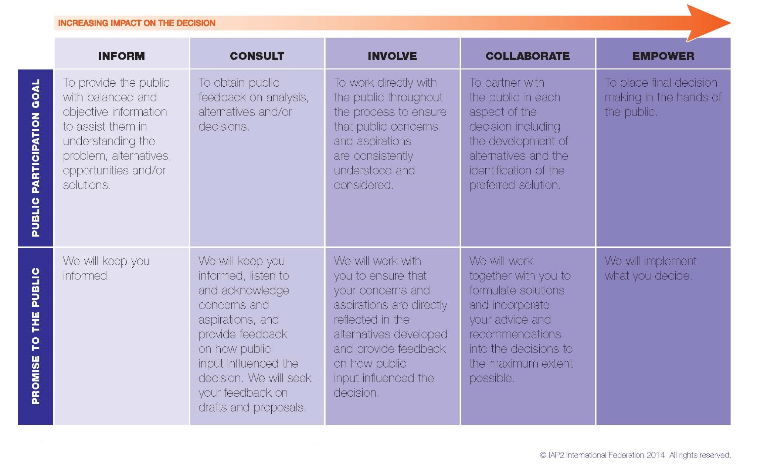
Figure 1: IAP2 Spectrum:
Figure 2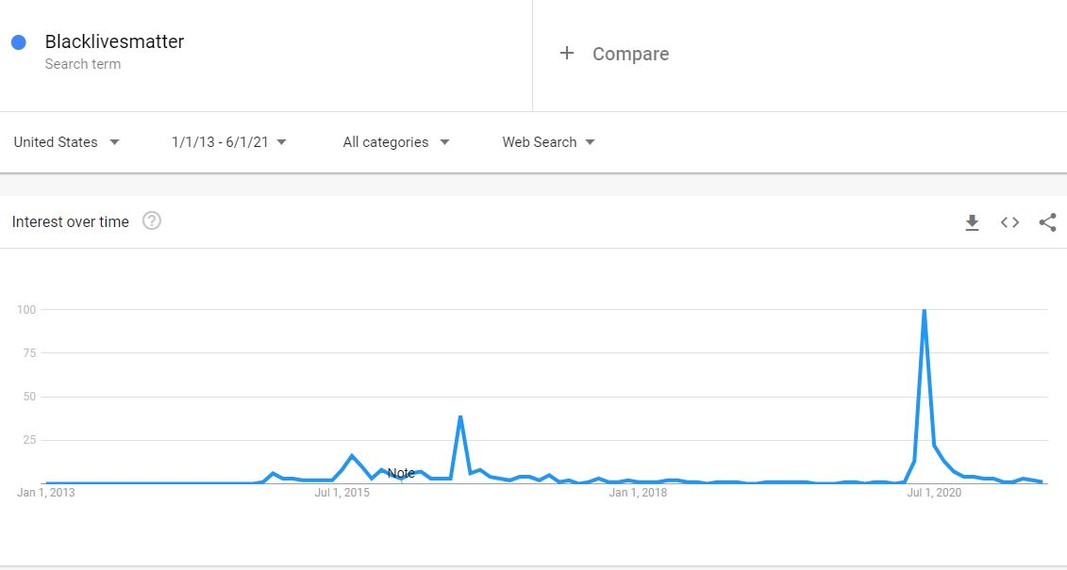
Figure 3
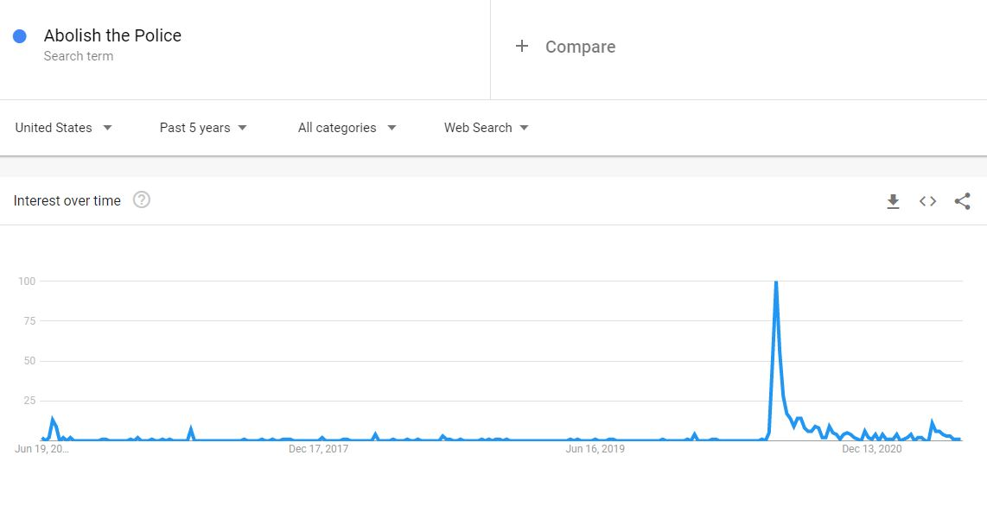
https://trends.google.com/trends/explore?date=today%205-y&geo=US&q=Abolish%20the%20Police
Figure 4: Methods of Communication

Method of Notification | Description | Additional Considerations
Website | - General Information in multiple languages.  - Download hub for fact sheets, additional resources, recorded meetings, etc.  - Previous Meeting Summary / Minutes  - New Meeting location information, how to get there (with public transit), description, and reminder sign up. | - Technology has already changed the “how” of public participation… As such building out a website that is accessible is crucial for future communications.  - Website address will be clear and visible on all project material (i.e fact sheets, hand outs, etc.)  - We have budgeted for a web designer to create an easy to navigate website.  - The team has also included space in the budget for a webmaster to maintain and update the site.
Additional General Information Channels | - Email: Create e-mail addresses specific to the project team and project.  - Phone: Create a phone account for the project team and project.  - Phone: Create a voicemail box for voicemail commenting.  - Phone: Link voicemail box to project team email to ensure that the comment is recorded and captured.  - Social Media: Create and manage social media accounts (Twitter, Instagram, Facebook, Youtube).  - Social Media: As meetings are scheduled informational posts will be created detailing the 5 Ws (Who, What, When, Where, and Why).  - Social Media: Partner with existing City of Compton Facebook, Instagram, Twitter, and Youtube page to advertise upcoming meetings and opportunities.  - Social Media: The City of Compton also has an instagram for the district supervisor, healthy Compton, and Fire Department. | - Although these points might not be as valuable during the early outreach stage they will serve as a foundation for future notification.  - We have included an IT and Social Media Team in the budget to maintain and manage the Website and Additional General Information Channels.  - Thanks to the existing partnership between the project team and the Board of Supervisors connecting with existing social media accounts can be done relatively easily.  - All of these accounts no matter how small could be activated to ensure that upcoming engagement opportunities are advertised.  - This is most advantageous as we start to build our proposed Social Media Accounts.
Newspaper Advertising | - Newspaper: Advertise upcoming meetings through local and diverse newspapers.  - Newspaper: The Bulletin - Based in Compton since 1973 this is a long standing newspaper with weekly coverage.  - Newspaper: OurWeekly LA - Although not specific to Compton this newspaper was created in 2004 as a way to reach the African American Communities and provide in-depth coverage on issues that affect them and the communities they call home.  - Newspaper: Latino California - The LC is distributed from Huntington Park and surrounding cities and is a predominantly Spanish publication. | - Newspapers have been a staple of community engagement for centuries and as such should not be ignored in lieu of newer methods.  - The team has identified 3 newspapers that are distributed in the City of Compton and cover a diverse population. This list will be expanded as needed.  - According to the 2019 Census data just over 50% of the population speaks one other language than English. Data from the 5 year ACS revealed that the most spoken language after English was Spanish with over 30,000 speakers. As such partnering with a large latino centered publication like LatinoCA helps ensure that this community is informed.  - The Team will ensure that all upcoming meeting notifications are included in these weekly publications as well as status reports.
Direct Mail | - Letters address and mailed to individual community members located within 2 mile of the informational session.  - Letters will be sent out in English and Spanish with the five Ws to give logistical information.  - Letters: Sent home with elementary/middle school students in the lead up to the event.  - Letter: will have proper branding and link to the website along with a QR code that will navigate to the mailing list and sign up for future updates. | - Direct mail is one of the most tried and true methods of engagement. The project team is working under the assumption that not everyone has equal access to technology.  - Thanks to our partnership with the City we can attain mailing addresses.  - We have partnered with community organizations and direct mail will be sent out to members, volunteers, and supporters.  - The team has identified 5 sites dispersed throughout Compton and will send information to addresses located within a 1 mile radius of the meeting site.
Advertisements | - Ads: Bus Stop ads along the top five routes in the city of Compton.  - Ads: The team has identified local TV stations that target different populations and will run ads on these to direct people on how to get involved.  - Flyers: Distribution of flyers at City Hall during peak hours.  - Flyers at major shopping centers. | - Examples of paid ads could be Bus ads along designated routes.  - Example of unpaid distributing flyers / leaving flyers in community centers / hotspots.
Radio Station | Radio Station: Real 92.3  Radio Station: KJLH 102.3  Radio Station: Cali 93.9  Radio Station: KROQ 106.7  Radio Station: KBUE 105.5  Radio Station: KLOS 95.5  Radio Station: LA Sports 570 AM | - Media coordinator will produce short and engaging messages to be played on local radio stations.  - Given that over 70 percent of people living in Compton drive we will run ads on local radio stations to spread our message and direct people to either the hotline or the website.  - Ensure that message is clear about this process taking place in Compton and will roll out to other cities soon.
Community Partners | - BLM LA  - Critical Resistance LA  - Education for Liberation Network  - Californians United for a Reformed Budget (CURB)  - Color Compton  - Yetunde Price Resource Center  - Center for Sustainable Communities  - Operation Progress LA  - The Compton Initiative | - Grassroots organizations have been involved in this kind of work for decades. Their prior work has set the groundwork for the BOS decision and we feel that they would be invaluable partners both in reaching out to the community and providing education.  - Nabatchi and Leighniner also speak on the importance of partnering with others to achieve critical mass and tapping into established forums (Nabatchi, T., & Leighninger, M. (2015)).
Volunteer Door Knocking | Distribute informational flyers door to door within  500 feet of the five identified sites leading up to first and second meeting  - District One: Centennial High School  - District Two: Willard Elementary School  - District Three: Tibby Elementary School  - District Four: Compton College  - Central Site: Douglas F. Dollarhide Community Center | - Volunteer events present a great way for the community to interact with each other beyond the informational sessions. By hosting canvasing events within a 1 mile of each site we can ensure that the public will have more opportunities to interact with each other.  - Volunteer events also make great opportunities for photo-ops that can be used on the website and social media.

Figure 5: Map of Proposed Meeting Locations
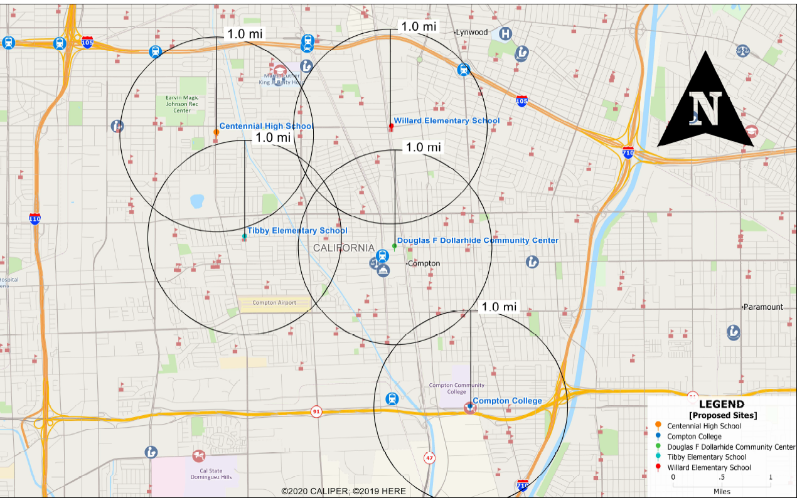
A
B
C
D
E
Location Name | Address
- Centennial High School | 2606 N Central Ave Compton CA 90222
- Willard Elementary School | 310 East El Segundo Blvd Compton CA 90222
- Tibby Elementary School | 1400 W Poplar St, Compton CA 90220
- Compton College | 1111 E Artesia Blvd Compton CA 90221
- Douglas F Dollarhide Community Center | 301 N Tamarind Ave Compton CA 90220

Figure 6: Compton District Map
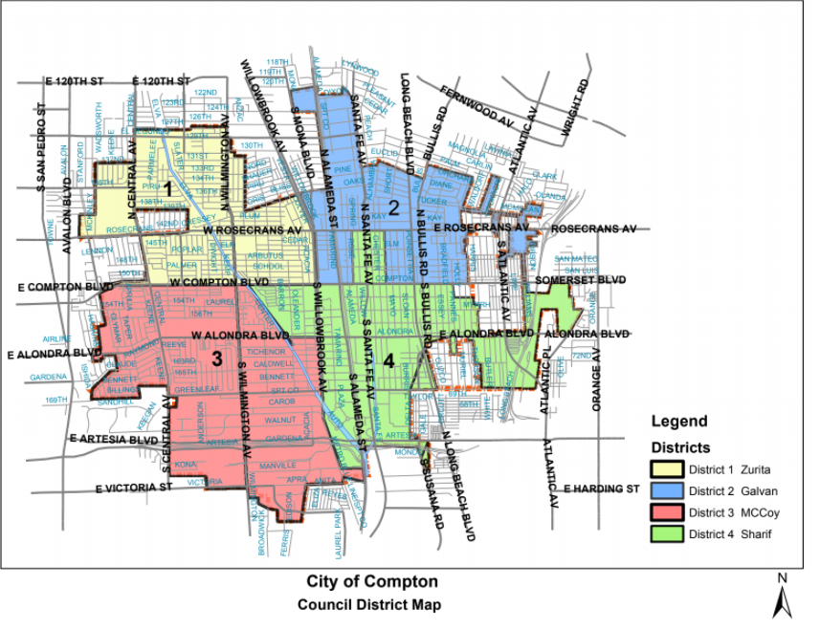

Figure 7: How-To-Zoom Template
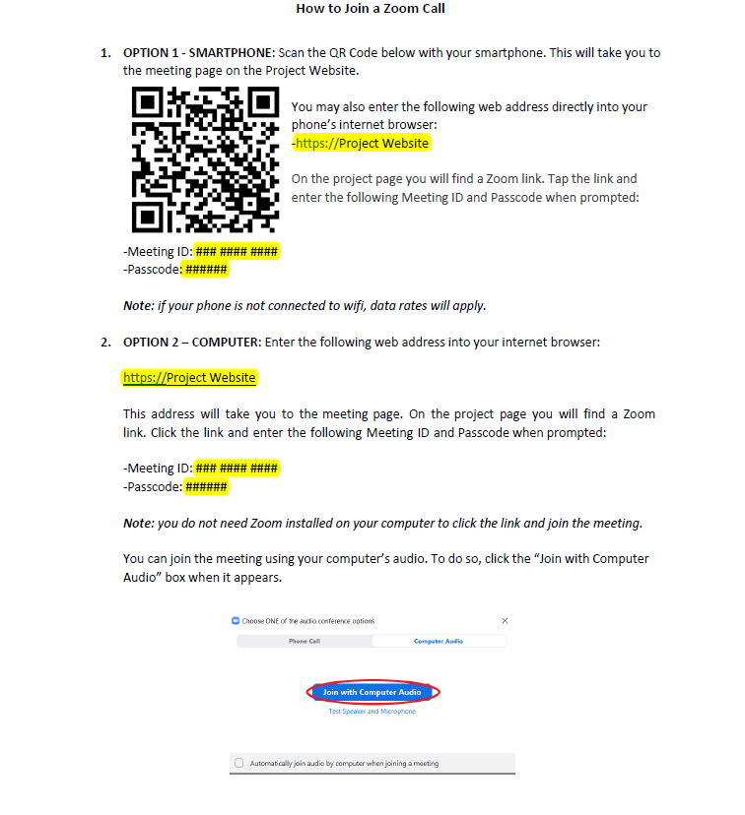

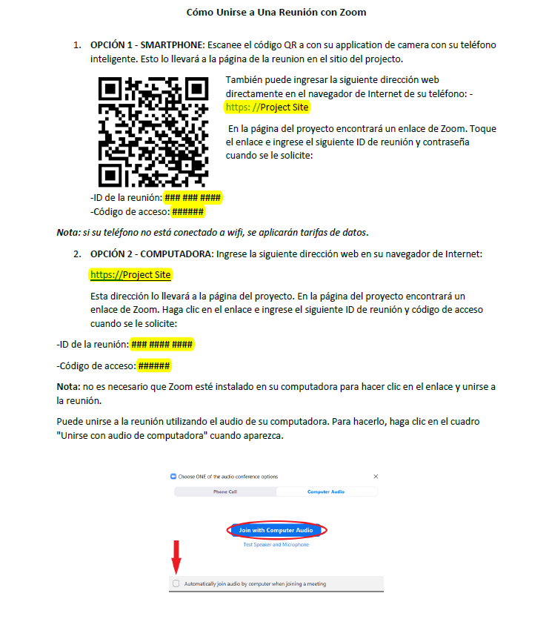

Figure 8:
Sherry Arnstein’s Ladder 1969
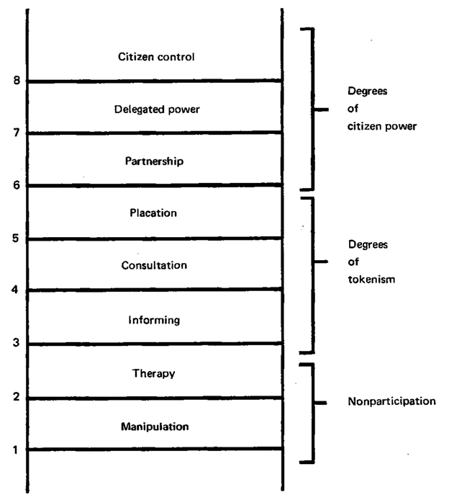

Figure 9:
Mock Website

